Chapter 1

Hamburg

Mum did not lift a finger to halt the rapid decline of our family.

With financial ruin written all over the sky she did not make the slightest effort to do anything about it - find a job? Stop smoking sixty cigarettes a day? Stop consuming vast amounts of alcohol every evening?

Mum sat, smoked and stared out of the window. She sat, mind you, she did not lounge or slouch or loll. She hardly ever reclined into her suite armchair; she only ever leant back completely into that armchair of hers when she wanted to make you understand how utterly fed up and exasperated she was feeling about something or other.

She just sat there, leaning forward, elbows resting on knees. In fact, both her legs had purplish/red bruises, dents almost, just above the knees where the elbows dug in, taking the weight of the upper half of her body so many hours every day. Her legs would be slightly apart, and her feet, comfortably clad in some old, flat, well-worn and snugly fitting indoor slippers, feet so tiny that she wore the smallest available ladies’ shoe size , her feet were continuously in motion, with a kind of nervous, automatic shuffling and scraping on the spot, wearing two distinct threadbare patches into the old Oriental carpet.

This was how she spent her days in the last years of our Hamburg life, when my Dad, Herbert J.R. Voss, started seriously to decline, both financially and in terms of his health.

She mostly wore dull and ugly beiges and browns, ill fitting, cheap polyester slacks and jumpers; there was a slight whiff of perspiration about her, and the odour of stale smoke clung heavily to her clothes; her hair hung lifeless, thin, lank, greying; her teeth were stained yellow by nicotine and dental neglect; her huge black eyes looked dull, deadened, blank; her formerly beautiful delicate hands had turned gnarled and bony, the joints swollen and distorted with arthritis.

She sat with an air of stubborn grumpiness and resentment, of ‘don’t give a damn about anything anymore’. Sometimes she would look sadly lost in thought, then suddenly she would sigh deeply, mutter resignedly “yah, yah” and stub out her cigarette in the ashtray in front of her.

And I noticed an unfamiliar note of cold contempt in her voice when she addressed my Dad, as if she deeply despised him and could not be bothered with him anymore, and she did not seem to take much interest in my life either, or in anything else, for that matter. So she sat, and smoked, day after day, month after month, year after year, and our small Hamburg flat (we were living in a middle class suburb on the eastern outskirts of the city because we could no longer afford anything better) was beginning to look distinctly shoddy, dusty and nicotine stained.

My Dad had given up cigarettes at some point (he used to smoke the strong Benson & Hedges, expensive-looking in their elegant all-golden packet) and had turned himself into a devoted pipe smoker; our large, heavy lounge table bore his pipe paraphernalia, a pipe stand holding his carefully crafted pipes, pipe tobaccos in neat leather pouches, a book on pipes even. This book had been the cause of an unpleasant row between Mum and Dad, for she had given it to him as a Christmas present but then got furious when he wanted to read it instead of giving his full and undivided attention to her.

Of course, none of all this helped to conceal the fact that Dad, too, had lost his former aura of expensive elegance, he now chose to wear more ‘leisurely and ‘comfortable’ clothes, and he began to look heavy, big and heavy, and Mum, too, had put on quite a bit of weight over the years and had developed a substantial Buddha-like belly.

So Mum sat, morning, noon and night, and as things got worse and each of Dad’s business ‘projects’ went down the drain, he spent more and more of his day sitting in his place on the lounge sofa, thoughtfully puffing his pipes. In the evenings they would have glasses of beer, accompanied by small glasses of strong cheap Schnapps, and Dad would dutifully keep both the beer and the Schnapps glasses topped up until Mum declared that she was “very tired now” and they went to bed.

The general atmosphere in our home had become subdued, my parents sat looking tense and worried, and silences hung heavily in the air.

That was the only time I remember giving any serious thought to my future and I decided that come what may I would not end up like Mum, or like Dad, for that matter, and I made a conscious effort not to be like them. I would study and work and get myself a solid foundation for a secure income, and I became convinced that anything to do with ‘management’ or ‘business’ and financial dealings was highly dodgy and dangerous and ultimately ruinous.

I suppose that in many ways I did succeed in becoming quite the opposite of Mum, with one exception: in spite of a lot of battling and struggling I became and remained a smoker, like her.

* * *

The first years of my life were spent in a very different part of Hamburg. In those early years (I was born in 1952) we lived in an up-market rented flat in the heart of the city, in a very posh, wide and leafy street called An der Alster , which runs along the waterfront of Hamburg’s huge and beautiful lake. The houses in this street are great imposing buildings, residences of the city’s grandest and most renowned hotels, homes of foreign consulates and of various enterprises of the highest reputation. The magnificent views across the wide expanse of the Alster with its many sailing boats and unique little white ferries, its ducks and swans and willow trees, its beautifully manicured pavements and landscaped flowerbeds and pretty little lakeside restaurants have been countless times reproduced in colourful picture postcards as one of Hamburg’s major attractions.

My parents were well off and could afford a live-in nanny/housemaid; so they could do what they enjoyed doing most, going out at night to dance and dine.

In one of my earliest memories of Mum she is preparing to go out for the night: she is sitting at her highly polished dressing-table which has a large centre mirror and movable mirrors on either side so that one can view one’s reflection from different angles. She is looking very glamorous, dressed in a wide-skirted, shoulder-free, low-cut 1950s party dress and elegant dainty high-heel sandals. She is brushing her thick jet-black shiny hair back in dashing sweeps, applying rich-red lipstick and face powder, rouge and mascara, delicately dabbing drops of exquisite French perfume (Crepe de Chine) behind her earlobes and on the inside of her wrists. Her long, beautifully shaped and manicured fingernails are varnished in a deep red colour, and she is wearing her special jewellery, a tiny and infinitely dainty gold evening watch with a slim, black, carefully designed strap, and on her right arm her set of Indian gold bangles which make a lovely tingly sound when she moves. From her earlobes dangle finely ornamented moon-crescent earrings which enhance her Oriental and gypsy-like appearance; on her dressing table sits a pretty white jewellery box from which she chooses a jingly golden charms bracelet; and I know that each of its charms has a special meaning and a story to tell.

She looks like someone who has walked straight out of a Hollywood film into my life, and while I stand there in my pyjamas, ready to be put to bed by the German nanny, I gaze at this amazingly gorgeous and perfect being and she is my Mum and she is the most wonderful person in the whole wide world. I get a glimpse of the life she must be enjoying when she is away from me. She is in a happy, excited mood and the world out there,-her world-, seems a place full of sparkle and fun.

After a few minutes she gets up and puts on her black velvet evening coat, picks up one of her dainty, glittery evening handbags, gives me a hug and a kiss and she and my Dad sweep out of the flat and into their life of glitz and glamour…

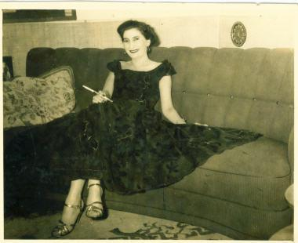

Mum in our Hamburg flat, 1950s

My Dad, of course, would also be exquisitely dressed; in those days he wore nothing but elegant, tailor-made suits of the highest quality; I remember spending Saturday mornings with him picking up shirts from the drycleaner’s, and visiting the tailor’s shop for a fitting session or to collect a finished suit. His tailor, a friendly, chatty man, had the most enormous table I had ever seen.

* * *

Armenia/Persia

As the 19th century was slowly and relentlessly drawing to a close and a new global era was preparing itself to emerge with turbulent spectacle, a family, living tucked away in a small and insignificant country, made a fateful decision. The little country they were living in was Armenia, and apart from the fact that Armenia was the historical and cultural, if not always political, home of Mount Ararat, the Biblical mountain where, according to Judeo-Christian theology, Noah’s Ark came to rest after the Flood, it could not lay claim to having much prominence or say in the matters of the world. However, its people, who are said to have been the world’s first Christians, were being gruesomely slaughtered in nightly raids by their neighbours, the Muslim Turks of the Ottoman Empire. This first wave of persecution was to culminate 10 years later in a full-blown Genocide, all of which caused a growing wave of migration, and Armenian families were inevitably on the move out of their homeland which most of them would never see again. The refugees fled into the surrounding countries; Armenia was fatefully positioned on the boundary between the European East of the Christian West and the Asian West of the Muslim East. Many turned north and west and settled in Russia and Europe, or moved on to America, but this particular family decided, like many others, to make its way southeast into neighbouring Persia (Iran) where it joined an Armenian community already living there. The details of all this are lost in the mists of time, and only four pieces of information have been carried over into the minds of the present-day generation of this family: the fact that the Turks had massacred a myriad of Armenians, the name of a town, Julfa, the name of a woman, Sophie Bagram, and the recipes for two Armenian dishes…

* * *

Hamburg

Both my parents came from affluent families, and they both knew how to move with poise and confident politeness in the higher circles of society. My Dad was what you would call the ‘perfect gentleman’, always politely lifting his hat to passing acquaintances or neighbours, always impeccably groomed and dressed. He came from an upper middle class North German family with high cultural and educational standards and a refined lifestyle. He was a tall man with an imposing air about him; I do not remember seeing much of him when I was child; during the day he would be at the office where he worked as a business executive, and in the evenings he would take my Mum out to dance and dine. And at the weekends my parents would not emerge from their bedroom until the late morning.

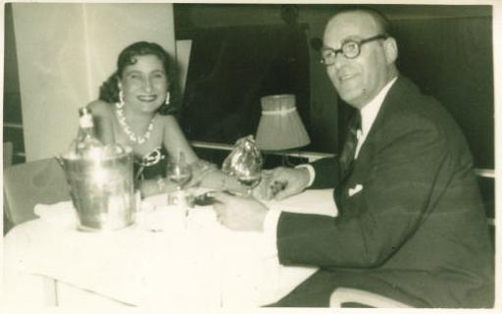

Hamburg, 1950s,Mum ( Gladys) and Dad ( Herbert)

During the week Mum would be at home with me and the Kindermädchen (the German live-in nanny), and I remember my mother mainly sitting and reading her books. Every so often she would take me to the American library which happened to be close by, and there she would happily and animatedly chat to the librarians and choose her reading material for the next couple of weeks. Perhaps this was a place where I became dimly aware that Mum was somehow different, and it had something to do with the way she talked to certain people. I cannot remember when I became conscious of the fact that I was growing up in a bilingual environment, but Mum used to tell me how it amazed her that when she told me in English to say something to the Kindermädchen, I would go and talk to the maid in German without realizing that I was translating from one language into another. Mum and Dad only ever spoke to each other in English, and I picked up my German from the maids; for reasons of her own, Mum refused to make an effort to learn German.

The maids in our household changed frequently, I think because Mum did not get along with them very well. When I was a very small we had a maid called “Beefy” (at least that was what Mum chose to call her in our home, perhaps because “Beefy” was a very large and heavy woman ), and the only one I have any memory of is Gerda. I seem to remember that Gerda left, and later on, after we had had a succession of other Kindermädchen, she returned to work for us.

Mum often told me, with great indignation in her voice, of a couple of infuriating incidents concerning the conduct of the maids; once she had carefully dressed me in a certain outfit, upon which the German Kindermädchen wordlessly led me to the bedroom and changed me into a completely different outfit which she deemed more appropriate. Mum was furious that someone dared overrule her like that. A worse incident involved Mum walking into the kitchen and witnessing the German maid giving me an old and stale piece of bread to eat while she was helping herself to succulent slices from a fresh loaf. The maid saw nothing wrong with this, young children should not be spoilt, she declared.

I remember a succession of German Kindermädchen taking me on agonizingly long walks all around the huge Alster; these walks took hours to complete, and by the end I would be crying with pain and exhaustion. It was also their duty to take me to the Kindergarten, and, from the age of maybe three or four, to the children’s ballet lessons at the renowned Lola Rogge School of Ballet. One day, when I was about four, on the way to a ballet lesson, the German Kindermädchen and I stopped at the traffic lights of a pedestrian crossing on our wide and rather busy street which runs along the waterfront of the Alster. Instead of taking my hand and leading me to the other side of the road she told me to run along ahead of her across the street. I did as I was told, hugging a brown cone-shaped paper bag full of delicious hazelnut kernels; I never got to the other side. A car knocked me over. All I remember is crying because my hazelnuts were scattered all over the road. I was taken home immediately and Mum nearly fainted when she saw the blood on my face and clothes. Luckily, there were no serious injuries, and all that remained was a slightly scarred eyebrow. The German Kindermädchen was given notice immediately

On the whole, being an only child in our little household, I had a quiet and uneventful life in those early Hamburg years; I was small and thin, and quiet and very shy. Mum would sit engrossed in the books she was reading, smoking her cigarettes, and I would play with my dolls and my toy grocery shop which was the size of a traditional doll’s house. Sometimes Mum would read a story to me from my English picture book of fairy tales; my favourite tale was Snow White and the Seven Dwarfs, and in my eyes Mum with her black hair, white skin and red lipstick lips looked just like the Snow White from my picture book. Sometimes I would nag at her to play with me and she would reluctantly put down her book and be a customer in my toy grocery shop for a little while.

* * *

Persia/ India

The Bagram family, for reasons unknown, did not settle in Persia for good, although they lived there long enough for the younger ones to learn to speak Persian fluently. So what happened? One might speculate that terrified Armenians, fleeing out of Armenia, brought news of massacres and exterminations of hitherto unheard of dimension and scale, which would have spread fear and panic amongst the Armenian Diaspora; perhaps this ignited an archaic survival instinct which swept the exiles into further migration. Whatever the case, the family made another fateful decision, to continue to move east to a city in India which had a rich and thriving Armenian community. By around 1920 they had firmly settled down in Calcutta which was to be their home for the next 30 odd years. We do not know the date or exact circumstance of their arrival in Calcutta, apart from the fact that they travelled part of the way by caravan, some of them riding on donkeys; what we do know is who arrived: Sophie Bagram and her five children, some of whom may have been still quite young; Sophie had three daughters, Mary, Elizabeth and Helen, and two sons, Sarkis and Vaughan. According to the family saga it was the second oldest child, Elizabeth, aged only 14, and her older sister Mary who first joined a caravan and travelled, - on their own -, all the way to Calcutta; then, at some later point, they arranged for their mother and siblings to join them.

* * *

Hamburg

The flat we lived in was by no means huge or grandiose; it consisted of a lounge, a dining-room, my parents’ bedroom, and a rather small room which eventually became mine, but for a while would have been the maid’s room. I do not know where they kept my cot , whether in their bedroom or in the maid’s room, but I do remember my first proper bed being in the small room, and curiously, I vividly remember a strange dream I had one night in that room. I must have been four or five years old, and I dreamt that I was in my room and looking out of the window into a vast, cold and pitch black night. Suddenly the moon appeared, looking very yellow. The moon silently and purposefully floated straight towards my window and extended a long metal arm. And just as the moon was immediately outside my window, looking no larger than a ball, its metal arm rattled at my window and clanked it open. Then it gave me a strange, knowing look and quietly and meaningfully sailed past. It seemed very real, that dream.

We lived in a small but beautifully furnished home; Mum had a talent for making a place not only cosy and vibrant, but also unusual and interesting; there were Indian brass ornaments and soft cushions in deep vivid colours; exotic pictures and mysterious ornamental objects, some of which my Dad had brought back from his numerous business travels to Africa and the Middle East. The furniture and lamps corresponded to the latest fashion of the Fifties; we had a kidney shaped, glass-topped coffee table on which were placed various fashionable ashtrays and table lighters

My parents put a lot of thought and effort into the interior styling of our home; wallpapers and curtains were carefully chosen to blend in with the overall effect, and some of our wall and table lamps had yellow and red bulbs in them which would bathe the lounge in a warm and diffused light; but the most striking feature of our lounge was the “bar”. It had a high, semi-circular counter with just enough room for one person to stand behind. and my Dad was the hobby ‘barman’; here he would stand with shaker and mixer and, strictly following the recipes, produce sparkling, colourful and unusual cocktails. On the outward-facing surfaces of the bar’s side panels were hooked our rather valuable and continually growing collection of miniature bottles; these were precise small-scale replicas of well-known brands of alcohol, anything ‘fancy’ that did not have a full-size equivalent was not permitted in the collection.

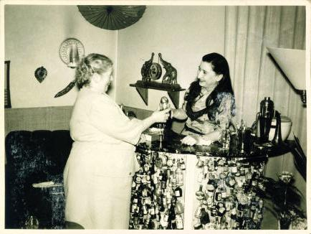

Mum at our “bar” with Tante Idel, a family friend
Hamburg, An der Alster, 1950s

When people came to our flat they would inevitably gaze around in awe and amazement; and my parents would glow with pride. Against the backdrop of Germany’s recent unwholesome past with its austere, cold, and monumental Nazi fashions and its psychotic elimination of anything faintly un-Germanic our home must have indeed seemed quite unusual and progressive.

My parents were fun-loving people, and I learnt from an early age to look upon smoking, drinking and partying as the essence of grown-up life. Mum smoked heavily, even through pregnancy (the Medical League had as yet not declared smoking to be harmful), and I hardly ever saw her without a cigarette. But I loved the smoke and the way it wafted and curled through the room, its particles mysteriously catching the light, ghostly entities from another world, a world in which smoking was good for you.

Mum loved to tell me, over and over again, the little anecdotes surrounding my arrival in the family. Mum’s family lived in London, but when Mum was in the last stages of pregnancy her mother, my Nana, and her aunt, Nana’s older sister Mer-Mer (pronounced ‘mare-mare’, as in the first syllable for Mary) happened to be visiting a famous place of Christian pilgrimage, the holy site of the Sanctuary of Our Lady of Lourdes in south-western France; Mum was anxious for her mum and aunt to be with her when the baby arrived, and she kept phoning them in their hotel in Lourdes and urging them to come to Hamburg immediately, because she felt the baby was due anytime now. But Nana simply told her not to worry, the baby would not be born before she and Mer-Mer were at her side. So Nana and Mer-Mer arrived in Hamburg in their own time, and Nana was right, I was not born until shortly after their arrival.

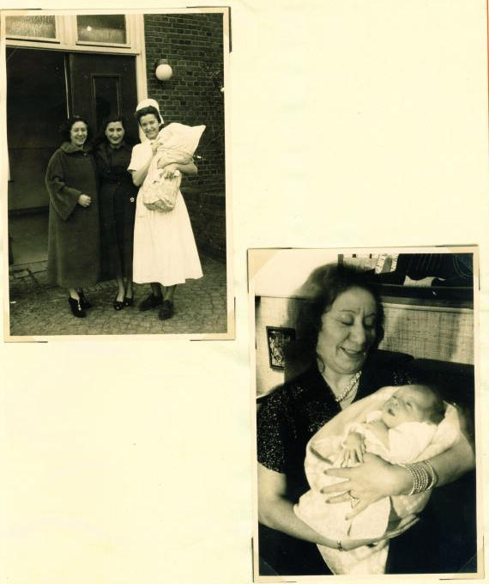

Above: Nana, Mum, and the German hospital nurse holding me
On the right: Nana in our Hamburg flat, holding me

It happened after my parents had had a long and wild night out. Mum had felt like being reckless, and had persuaded my Dad to take her on her first ever rollercoaster ride at the Dom, Hamburg’s huge seasonal funfair; she found the experience truly terrifying and screamed at the top of her voice; she never went on a rollercoaster again. A short time later the labour pains started, and I was almost born in the taxi on the way to the hospital; she struggled desperately to hold the baby in. I was born at 6.05 a.m. in the morning. That same afternoon, as she was looking out of the hospital window at a bleak and cold November day, it began to snow, and snow was something which, so she proclaimed, she was seeing here for the very first time in her life. She took this to be a good omen. Everybody was happy.

But there was one oddity to which Mum drew my attention over and over again; I had been christened twice. There had been a christening in Hamburg and then another one in London, this one by the Armenian Church.

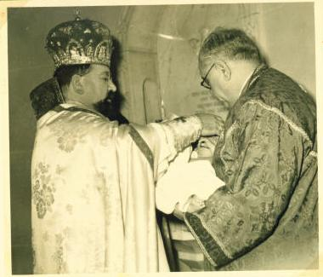
Christening in London by the Armenian Church

Life in those early Hamburg years became more interesting when Richard was sent over for his summer holidays. Richard was seven years older than me. He was Mum’s son from her first marriage to an Englishman, and he lived with Mum’s family in London. It did not strike me as odd that he was not living with us in Hamburg, and I was to learn later why this was so.

Richard knew how to play. In no time at all a stool became a steering wheel, a cushion a seat in a racing car, a rug a race track. Once he brought along some of his own toys, a large collection of tiny soldiers and army tanks which he would set up in rows and shift around in a significant way, and with a concentrated look on his face. And a lot of time he spent in the corridor of our flat practising a certain move which involved throwing something imaginary with an outstretched arm. Something called cricket, whatever that was.

By far the most exciting and memorable events of my childhood were the visits to Mum’s large family in London, which happened either for Christmas or in the summer. The family lived in a large, very-English looking house; it was made of red bricks, and it had bay windows and eaves, and a porch, and a front garden with a spacious front drive, and, bordering the pavement, there was a black wrought-iron fence with two long gates to let cars through.(we used to get told off for swinging on those front gates).

Grafton House was always full of people and children. My Nana was the owner and the head of the household, but it was her older sister Mer-Mer who got up at four o’clock in the morning, lit the fires, and made the tea. Mer-Mer had a large table in front of her bedroom, in the hall on the first floor, and here she would keep her large tea pot hot with a little stove and a tea-cosy, and keep handy sugar and tinned milk, and everybody’s favourite tea cup or mug. I used to be put up in Mer-Mer’s bedroom, sleeping on a camping-bed at the foot of her large double bed, and the moment I woke up Mer-Mer would hand me a large white porcelain cup of hot and strong, sweet and milky tea. What bliss. Mer-Mer herself had an odd tea-drinking habit: she poured small amounts of tea from her tea cup into her saucer, and then sipped the tea from there.

Mer-Mer was the one who did the everyday shopping and most of the catering; during the morning and day she was mainly to be found in the kitchen, getting sizzling breakfasts of bacon and eggs ready, then cooking vast amounts of food, delicious curries or stews, dhal and mountains of rice or pilau; she would often be joined by Nana in the hot, steamy kitchen; and the two of them would busily work away at their immense pots. No matter what time of day, there was always wonderful cooked food ready for whoever felt like having a hot meal. There were no set dinner times in that house.

So this was where my brother Richard lived when he was not at his boarding school. Lots of people lived in Grafton House, uncles and aunties, and cousins to play with.. And then there was the snow-white cat called Snowy, and Nana’s black dwarf poodle called Tina-kins. And a large chicken which lived in the garden. Grafton House had seven large bedrooms, two lounges, a big dining-room, a kitchen, a breakfast kitchen, several bathrooms, a garage, and a huge garden. I loved being in Grafton House.

Calcutta

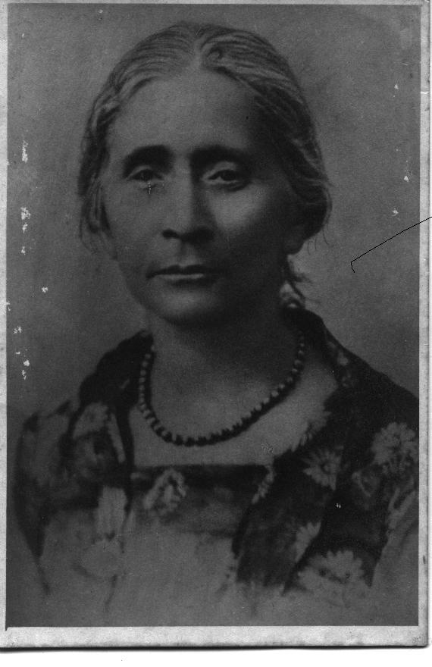
Sophie Bagram
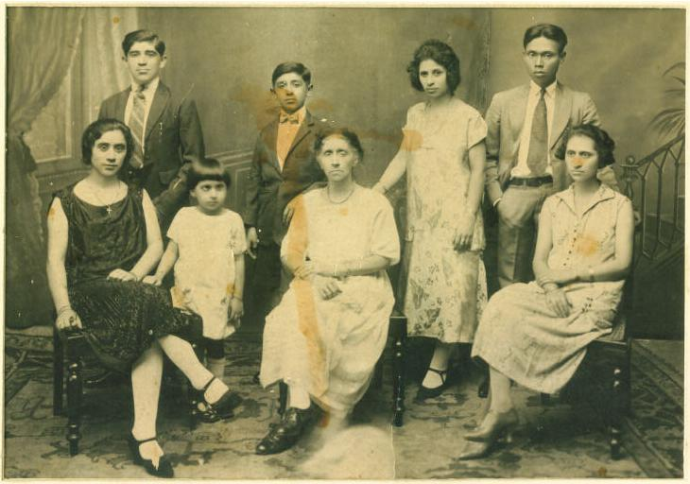
Sophie Bagram and her family, from left to right: Elizabeth (Nana), Sarkis, Gladys (Mum), Vaughan, Sophie, Helen, Marcellino Mendoza (Mary’s husband), Mary (Mer-Mer). This photo was taken in Calcutta in the 1920s It is the earliest picture I have of my mother

Within a few years of arriving in Calcutta, the Bagram family had a fortune and a lifestyle which afforded them to live in grand houses and to employ a considerable number of Indian servants. This was the lifestyle of the British who in those days were the possessors and rulers of India. How did the family manage to become so rich in such a short time? It is said that Sophie Bagram’s second oldest daughter, Elizabeth, married a very rich man. He was a Lebanese by the name of Joseph Khayat. It is said that shortly after the marriage he went to war and never returned. Elizabeth inherited his fortune and multiplied it by investing in shares and real estate. Forthwith she and her family lived in beautiful large mansions; moreover, she bought land in Darjeeling and had a villa built on it as a family retreat for the hot monsoon months. She called it Sophie Villa .Elizabeth always kept her entire family under one roof, even as it grew, and grow it did. She herself had a daughter whom she called Gladys; her older sister Mary married a Filipino jazz musician and became Mrs Mendoza, but the marriage did not last, and her husband disappeared from the scene; Mary remained single after that. but she had one son, Charlie; Elizabeth’s younger sister Helen married an Englishman, became Mrs Wilson, and had two sons; Elizabeth’s brother Sarkis did not marry but fathered a boy and a girl with some Anglo-Indian or Indian woman, and died young; and her brother Vaughan remained single while living in Calcutta and acquired the reputation of being quite a ‘ladies’ man’. Elizabeth’s mother, Sophie Bagram, died when Elizabeth’s daughter Gladys was in her teens.
*
Agnes Gonxha Bojahiu arrived in India in 1929, aged nineteen. She first went to Darjeeling, then later worked in Calcutta. She was an Albanian Roman Catholic with a calling to be a nun, and she was to become world-famous as Mother Teresa.

Hamburg

Dad worked as a business executive in the sales office of a small but rather successful company called Bauscher & Co. which made and distributed diesel engines. The founder and owner of this company, Christian Bauscher, was my godfather. Mum always referred to him as ‘Old Man’ Bauscher. Dad was a very close associate of C. Bauscher’s, and was expecting to be made a partner in the business. It was for this company that he had travelled to Calcutta where he and Mum had met and fallen in love.

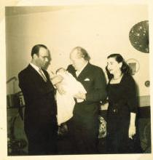

C. Bauscher (centre) at my christening
Hamburg, Nov. 1952

Even though I have no memory of C. Bauscher, he has retained a strange presence in my life. He wanted me to have a valuable and memorable set of cutlery, and he decided that he would give me individual pieces from this set every birthday and Christmas until I had completed the collection. This was no ordinary cutlery, it was made of elaborately ornamented heavy silver, and more than that, my godfather had had engravings put on each spoon, fork and knife: at the top end of each handle are engraved two capital letters, beautiful ornate italics, either CB for Christian Bauscher or KV for Kristina Voss.

My collection of silver cutlery remained incomplete. ‘Old Man’ Bauscher died when I was about three years old.

This event changed everything. Dad never did become a partner in the business.

My parents claimed that ‘Old Man’ Bauscher, who had no family of his own, had repeatedly shown them a thick envelope, stating that it contained his will, and stressing that when he died, Herbert, my Dad, was appointed to be his successor and was to take over the company.

But there was someone else in ‘Old Man’ Bauscher’s life, a man very much younger than himself. One day, so I was told, he officially adopted this man, who was called Edmund, as his son, and they shared a home. It must be said that my parents tended to strongly imply that this liaison was anything but a straightforward father-and-son relationship…

When ‘Old Man’ Bauscher died, no thick envelope appeared. Only a thin one appointing his adopted son Edmund Bauscher as his legal heir. So Edmund Bauscher took over the company, and for some years Dad continued to work for Bauscher & Co., KG as an employee. But he was not happy. Perhaps he did not like having a younger man as his boss, perhaps he disagreed with Edmund’s style of management. My parents claimed that Edmund showed no interest in the company, and that he was taking the company ‘s capital and depositing it in a private account in Switzerland.

When researching for this book I came across a webpage dedicated to the history of Bauscher & Co., KG. It states that Calos Christiano Bauscher (born 1892), died, together with two employees, in a road accident in 1955. Apparently C. Bauscher had had a strong social streak, he had bought a holiday hostel in Miltenberg (the company’s production site) for his employees and he had given jobs and homes to many German refugees from eastern Europe. The webpage also mentions that C. Bauscher had a nephew called Edmund Posch whom he later adopted and who became his heir. According to this webpage Bauscher & Co., KG went bankrupt in 1967; and it speculates that the reason for this was probably bad management and excessively high withdrawals of capital from the company’s funds.

Whatever happened, my parents never completely got over this; they felt badly cheated and deceived. They were convinced that C. Bauscher’s will had been forged by Edmund, but they had no way of proving this (24 years later, the dark cloud of suspicion concerning the forgery of a will was to descend once again…).

There was talk then of moving to England. My Dad was keen to offer his business expertise to Nana and to help her manage her fortune, but Nana did not take up the offer, and my parents could never understand why she didn’t. It would have been the perfect solution, and it would have reunited Mum with her son and her family.

One time Nana came to visit us in Hamburg with her older sister Mer-Mer and with her boyfriend Uncle Bobby, a former bomber pilot from New Zealand, They travelled by car, trailing a little white caravan behind them.

My parents took them along to enjoy the nightlife of St/ Pauli, Hamburg’s large and notorious red-light district with its famous street and major tourist attraction, the Reeperbahn. Apart from innumerable brothels, sex clubs and nightclubs it had a large Bavarian-style Bierkeller called the Zillertal where a traditional Bavarian band, clad in knee-high Lederhosen and feathered hats, would play thumping oom-pah music. Both Nana and Mum had a talent for making a spectacle of themselves, and each of them was invited onto the stage, handed the baton, and asked to pose as the band conductor. A Zillertal photographer was at hand to take souvenir photos.

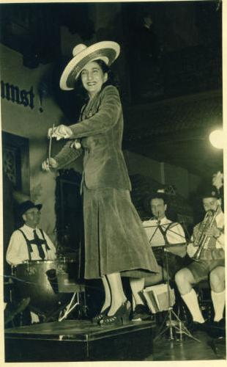

Mum at the Zillertal in Hamburg, 1950s

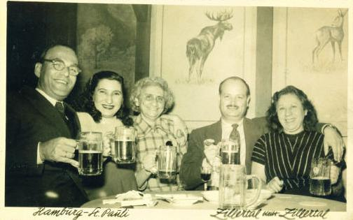

Hamburg, ‘Zillertal’, 1950s
From left to right: Dad, Mum, Mer-Mer, Uncle Bobby, Nana

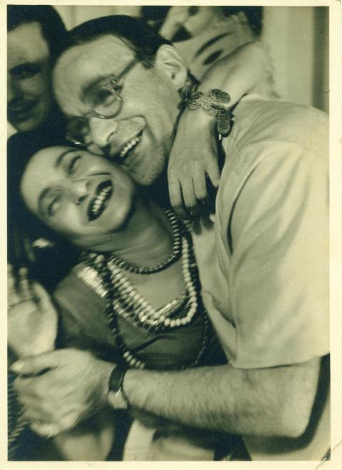

Mum and Dad, Hamburg, 1950s

What fun they had!

It was during this same visit that Nana one day decided to position her beautiful Persian samovar on the pavement beside their caravan and approach every single passer-by with the cheerful offer of a free cup of hot, sweet, milky tea.

Nana could be quite outrageous. Mum was absolutely furious when Nana declared that Herbert was sleeping with our German Kindermädchen. This was the most ludicrous thing she had ever heard.. Herbert wouldn’t dream of such a thing, besides, the German Kindermädchen was not in the slightest the type of woman whom Herbert would have given a second look. Apparently.

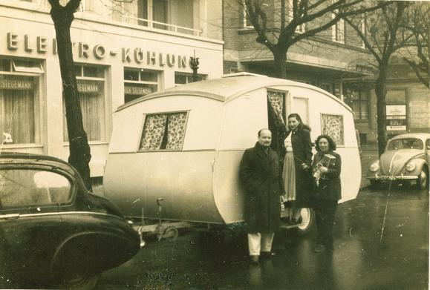
From left to right: Uncle Bobby, Mum, Nana
Hamburg, An der Alster 26, 1950s

For a while life just carried on., I went to Kindergarten and to my ballet lessons at the Lola Rogge School, and my parents had fun going out at night. One of the Reeperbahn attractions they particularly enjoyed were the spectacular mud fights where completely nude women wrestled each other in an arena of thick mud, rolling around and furiously clawing at each other. But most of all my parents loved dancing, and apparently they were so good at it that wherever they went, the dance floor would invariably empty as everyone stood and gazed at them performing a fantastic samba or rumba. They would drink and party until the early hours and Mum would laugh remembering how sometimes Herbert would just about manage to drive them home, but they would both be so tired that they would drop off to sleep in the car, parked in front of their flat, and not wake up until the late morning!

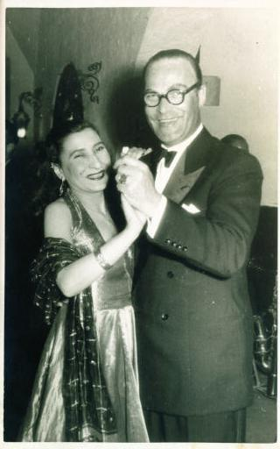
Hamburg, 1950s
Gladys and Herbert

Being a fun-loving person, Mum ensured that there was quite a bit of fun in my life, too. I was frequently taken to Planten un Blomen, Hamburg’s attractively landscaped city park and botanical gardens; it had a tiny train running through it on narrow little tracks which I loved to ride on; and there was a lot to explore, interesting narrow windy pathways and steps through rockery mounds and challenging stepping stones across little waterways, and in the summer there would be stops at the park’s ice- cream parlours. The park also had a large playground where I spent hours on the huge elephant-shaped climbing frame, in the big toddlers’ splash pool or in the large sandpit.

Then there were spectacular birthday parties with lots of children wearing party hats; the dining-room would be decorated with balloons, there would be crackers and cakes, and jelly and ice-cream on the table, and Mum would organize children’s party games with prizes to be won.

And if that was not enough, there were also big fancy-dress parties at the ballet school, and the odd performance at a Christmas pantomime, where our Lola Rogge ballet class would dance and hop around in fun costumes, dressed as little ‘fire devils’ or as bearded dwarves.
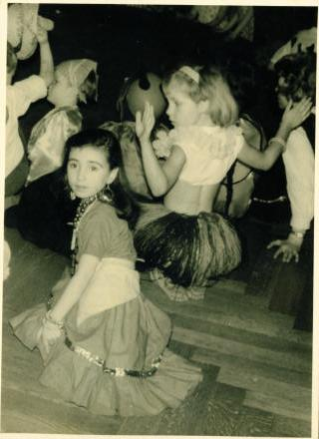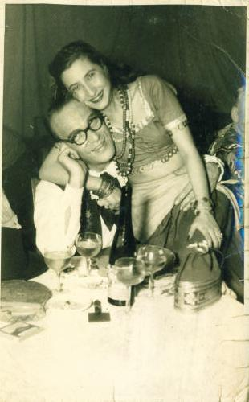

Fancy-dress party at the ballet school
Gypsy-Mum!

Hamburg, 1950s

Sometimes my parents would entertain people at home; many of these were employees from one or the other of Hamburg’s foreign consulates. Mum managed to stun everyone of them with her vivacity, her looks, her low-cut dresses, and her talent for making people feel welcome.

Dad had a close friend from before the war whose name was Henry. He was a bachelor and Mum liked him very much, but she was completely shocked when one day he declared in his heavy German accent: “I was a Nazi,, I am a Nazi, and I always will be a Nazi!”

There was also an old female acquaintance of Dad’s with whom Mum made friends. I came to know her as Tante Idel (aunt Idel, see “bar” photo on p.8). Tante Idel was a big, elderly lady and she suffered severely from diabetes, which meant she needed to inject herself with insulin every day. Mum felt very sorry for her, the more so as she was a kind and warm-hearted soul. Tante Idel was the landlady of a small local pub situated next to the city’s slaughter houses. We sometimes drove there, and on Tante Idel’s bar counter sat a big round glass bowl which was a dispensing machine for hazelnut kernels. I loved munching those.

Of course there was also Dad’s side of the family. Both his parents had died before he married my Mum. His father, who had been a merchant, died shortly before Mum arrived in Hamburg, and she always regretted that she had not had the chance to meet him. But while Dad was courting Mum in Calcutta, his father back home was in hospital, and Herbert wrote letters to him, describing his stay in Calcutta, his business progress, and the fact that he had made friends with a very rich Armenian female. (In those letters he calls her ‘meine kleine Armenierin’ – my little Armenian.)

Dad’s brother, Werner, and his sister, Ilse, both lived in Hamburg. The family had been completely bombed out during the Second World War, and had lost everything.
Dad had been in Hamburg all through the war, and as a keen hobby photographer he had taken a lot of pictures of Hamburg when it was being bombed; these photographs show the huge, black, menacing billows of smoke, the burning houses, the burnt-out ruins of buildings and churches. He told me that it was one of the civilians’ duties to keep pouring buckets of water onto the rooftops of their buildings to prevent the spread of fire from neighbouring burning houses. Neither his brother Werner, who had a weak heart, nor he himself had been in the military during the war. Dad had not been conscripted for two reasons: he suffered from varicose veins in his legs and the company he was working for, Bauscher & Co., KG, was considered to be ‘aiding the war effort’.

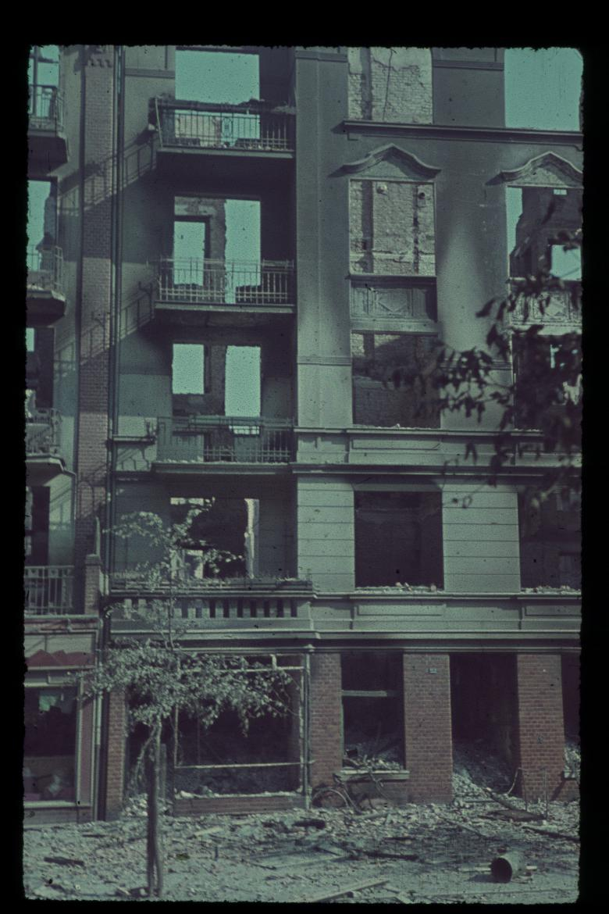
The bombed-out flats where my grandparents lived
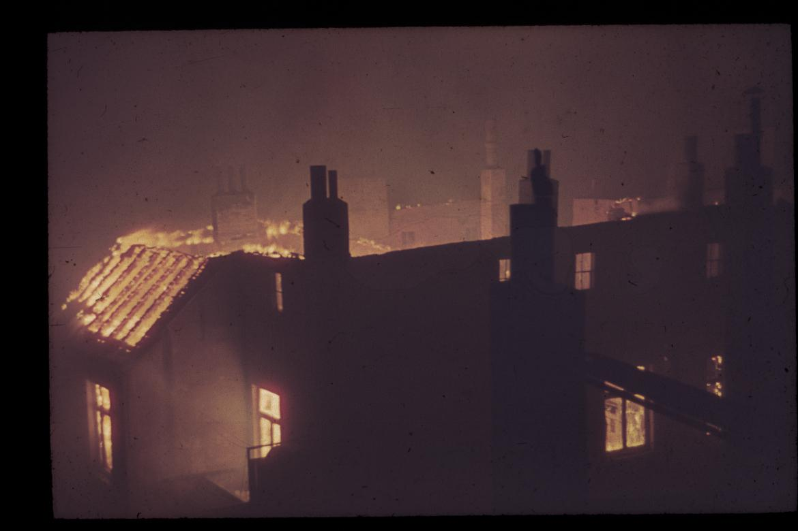
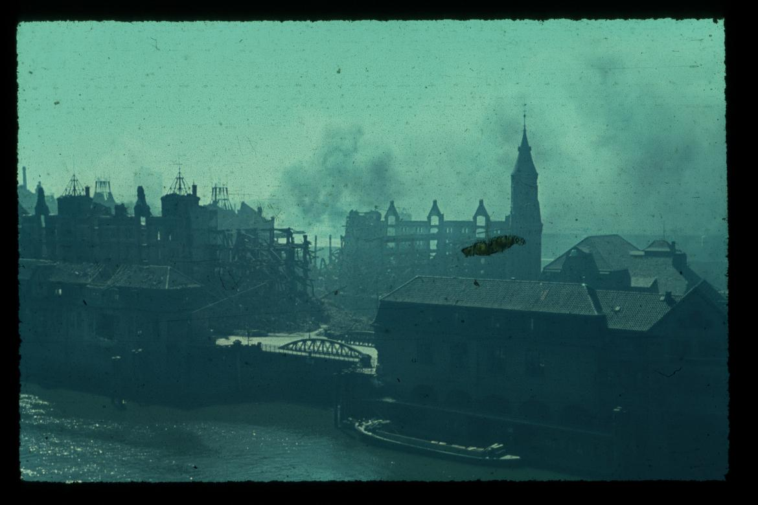

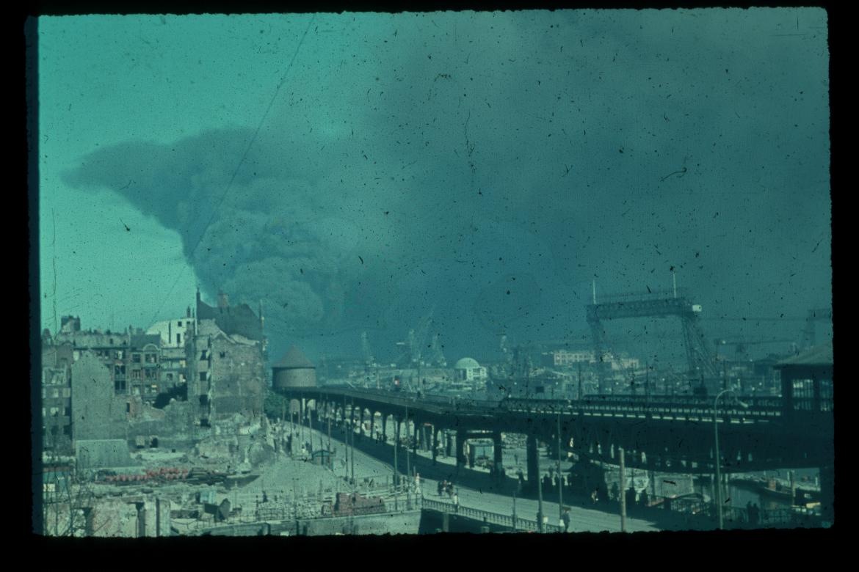

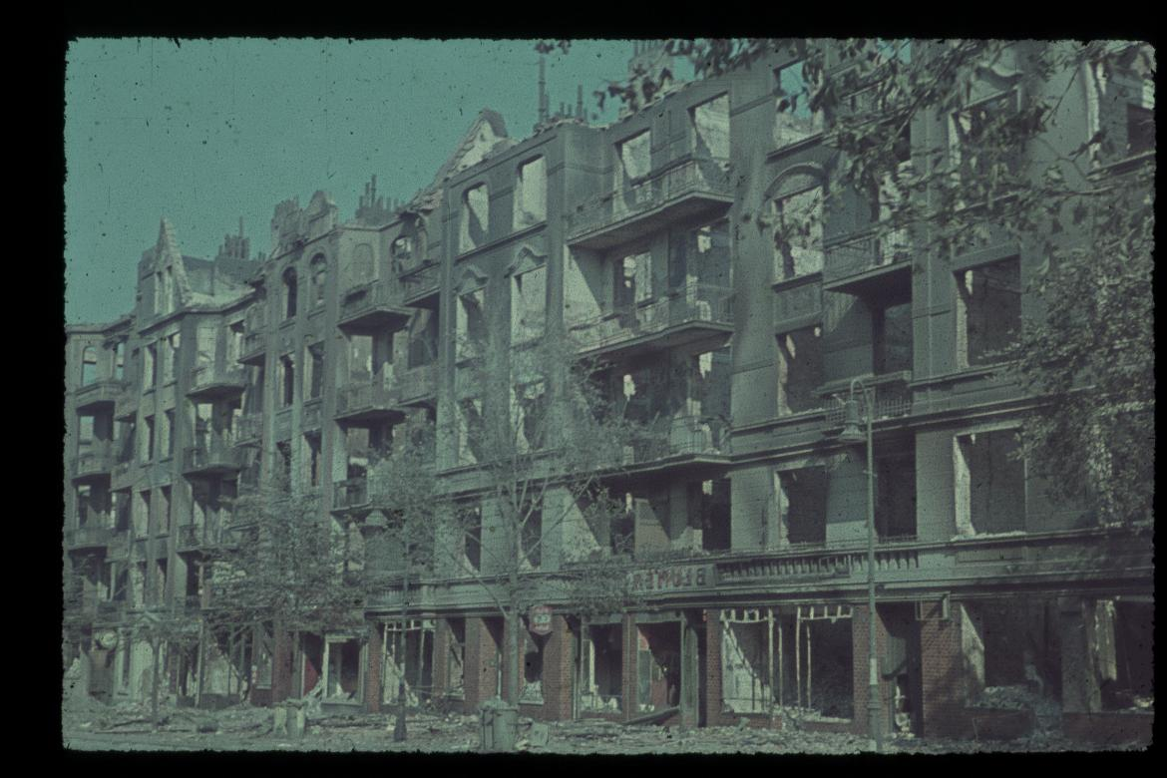

Dad’s photos of the bombing of Hamburg

Dad’s brother, Uncle Werner, was married to Aunt Claudia, and they remained childless; Dad’s sister, Aunty Ilse, was unmarried and was bringing up an illegitimate son on her own. She and her son Reinhard, who was about my age, were living in extremely poor conditions; Tante Ilse had studied art and was a painter and sculptor. She had had her own studio and a promising career ahead of her when the war destroyed all that. She now had to make a living working in employment.

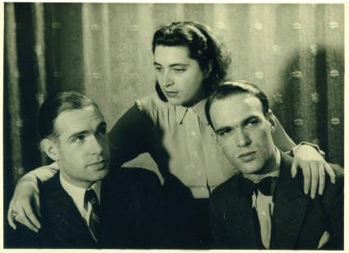

An older family photo, probably taken in the 1930s
From left to right: Werner Voss. Ilse Voss, Herbert Voss

Mum got on well with Dad’s family, as she did with Dad’s teenage son, Helmut, who sometimes came to visit us. Helmut lived with his mother from whom Dad had got a divorce long before he met Mum.

I think Mum particularly liked Uncle Werner, who was a soft-spoken, modest and kind man. She repeatedly told me that she would never have let Uncle Werner visit us when Dad was not around, for fear that people might get the wrong impression and start rumours. But why did she put so much emphasis on this?

Slowly. slowly, fate was staking its path. I was to remain my parents’ only child. But this was by no means Mum’s plan or intention, she very much wanted me to grow up in the company of siblings, and she had even once got pregnant again; but the German doctors had intervened; another pregnancy would be extremely dangerous, they had warned, so she had had no choice but to give in.

When I was approaching my sixth birthday, and with it school age, my parents and I were asked to attend an appointment at the local primary school which had to assess whether I was mature enough to start school at the age of six, or whether it would be better to wait another year until I was seven. I did well at the mental tests, but the school voiced concern that I was physically so very small and so very thin. This annoyed Mum tremendously and she pointed out that she herself was very small and very slim. It was decided that I should start school at the age of six, with the new school year, which would begin after Easter.

So eventually, in the spring of 1959, my first school day approached, and in Germany this was marked as a very special event. On that first day I, like hundreds of other children all over Hamburg, was escorted to the school (a short walk from our flat) by my parents, proudly carrying my Schultüte, a great big colourful cone full of goodies, chocolates and sweets and stationary. At last, I was going to learn to read and write; and from the very next day I would be walking to and from school all on my own! Early childhood had come to an end.

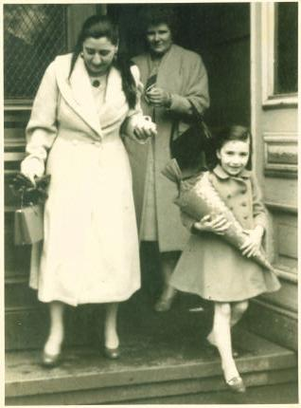

With Mum ,on my first day at school

Hamburg, 1959

As the 1950s were coming to an end things began to change for our family. Dad decided that he had had enough of Bauscher and Co and soon got offered an attractive, well-paid job by a company with which Bauscher & Co had business contacts. This new company, Modag, had its seat in Darmstadt, a town several hundred kilometres south of Hamburg, not far from Frankfurt. And so we prepared to move.

Mum started packing, and I helped. The first thing to be carefully wrapped in layers of newspaper and gently placed in a removal box was the delicate collection of miniature glass bottles from the “bar” Then we packed the ornaments and the pictures, and the books, and then everything else. We said our good-byes to neighbours, friends and family, and Mum tearfully parted with her Philodendron which had grown so immensely over the years that it had had to be trailed along the ceiling; it had forked out so intricately and expansively that she felt it could not be moved without causing severe damage to it, so she left it in the flat. The removal people came and loaded boxes and furniture into their big van, and we got into our car, said good-bye to Hamburg and began our long drive south.

Give or take a few months, at around the time when we were leaving, or had left, for Darmstadt, a band of five young musicians from Liverpool turned up in Hamburg, and played nightly gigs at a club on the Reeperbahn. Four out of these five were later to become world famous as The Beatles, and thanks to Richard, I was to become one of their earliest fans.

* * *

echoes from the past

Nana was only fourteen when she and her sister Mer-Mer left Persia for Calcutta. They joined a caravan. They rode on donkeys. The rest of the family joined them later.

Nana could not read or write, yet she became a millionaire.

Nana: “I am the cleverest woman in the world.”.

Nana: “Write my book for me”.

Nana: “Come to England. ”

* * *

