Chapter 3

London

The most interesting and most memorable events of those years still revolved around our regular visits to England to see Nana, Mer-Mer, Richard and the rest of Mum’s family. Even the journey itself was quite eventful and exciting, although it took long hours to get to Grafton House. Our car was packed brimful with our luggage and presents and German foods for the family, but the backseat was padded out with soft blankets and pillows and my duvet, turning it into a safe and cosy little haven for me to snuggle into (this was before seatbelts and children’s car seats were invented); there would, of course, also be a generous and most delicious stash of chocolates, sweets, and sandwiches on board.

We usually set off early in the morning, and it was not long before the car’s motion, the engine’s regular hum and the reassuring smoke from Mum’s numerous cigarettes put me to sleep. When I woke up hours later, we had left Germany and were travelling through Belgium with its odd looking street lamps, stopping in Brussels to admire the Atomium, that huge bizarre structure of tubes and spheres, and heading towards Ostende. The hours on the ferry were a tough challenge, having to sit indoors the whole time, feeling horribly sick, getting a headache now from my parents’ constant smoking; almost, but not quite, vomiting. But then Dover and fresh air and big signs telling you to keep left. England, at last. Another longish drive through countryside, oddly different because of the left-hand perspective, and the high hedges bordering the windy roads; then the streets of London, everything so different; smaller, closer and more colourful, a toy version of Germany. The houses small and low and identical and stretching endlessly; but one would have pink front doors and pink window frames, the next lilac ones, the next yellow ones; on and on, each a different colour; surely only cheerful souls could paint their houses the colour of sweets; rows of tiny shops and strange colourful advertisements on huge billboards, and little old ladies with quaint shopping trolleys and silver hair tinged purple, and bright pink rouge and lipstick; narrow roads, and the traffic so congested, and so slow, the soft dense air and the slightly sickening smell of petrol; big black taxis and red double-decker buses with open platforms and squeaky brakes; yellow blinking lollypop lights at zebra crossings, and the many roundabouts that make you feel carsick. The growing excitement as we approach the Blackwall Tunnel, not long now, the fun of the long eerie ride through the narrow tunnel, and then we are heading for Wanstead; another corner or two, and we are in leafy St. Mary’s Avenue, and there it is: Grafton House.

Up the front drive and we are surrounded by the family, big hugs and smiles and kisses; laughter, excited chattering, everybody talking at the same time; Tina-kins, Nana’s little black poodle, wildly wagging her tail, running circles around us and barking her high-pitched bark. Happiness.

If we were in Grafton House for the summer holidays, we usually stayed for at least four weeks, and settled into long, languid days, doing nothing much. It did not occur to my parents to take me sightseeing in London, or to the seaside, or to the zoo. There was no need for that, Grafton House provided all the entertainment one could wish for.

Grafton House belonged to Nana, and, apart from us, Nana had her entire family living with her under one roof. Mer-Mer, who was Nana’s older sister, was the next most important person in this family. Mer-Mer was old, always had been old, in our eyes. Even older than Nana. Mer-Mer had snow-white hair, always had had snow-white hair, and she wore slippers in the house. Nana was definitely younger because Nana’s hair was not white. Nana’s hair was reddish-black, and she even drove a car, a black car. Mer-Mer was much too old to drive a car. Nana wore presentable shoes with a certain amount of heel. Mer-Mer wore flat, sensible old-ladies shoes. But you could tell that Nana and Mer-Mer were really, really close. Both of them were on their own, having lost their husbands a long, long time ago, (although Nana had a boyfriend for a while, Uncle Bobby, a former bomber pilot from New Zealand); Mer-Mer and Nana were the ones who were bringing up Richard and sending him to a boarding school, in a place called Chelmsford, and looking after him in the holidays and putting him on the plane to travel to Germany. Nana and Mer-Mer were the ones in charge in Grafton House, and Nana and Mer-Mer were the ones who took it upon themselves every so often to travel to Germany to visit us.

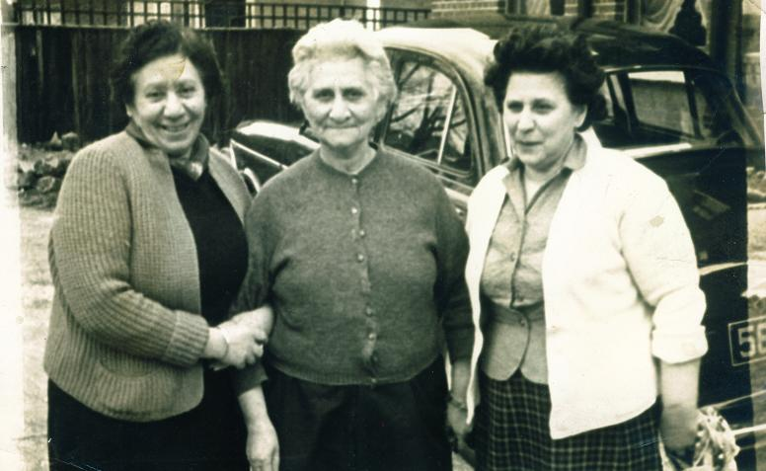
From left to right :Nana, Mer-Mer, Aunty Helen
On the front drive of Grafton House; in the background Nana’s car

There were two other family members in Grafton House who were old, like Mer-Mer’
and Nana: Uncle Vaughan and Aunty Helen. These four were brother and sisters. Of the four, Aunty Helen seemed the most distant, perhaps because she only half lived in Grafton House. The other half she lived in Calcutta, looking after Nana’s property there. Aunty Helen was forever travelling to and fro between India, England, and Australia where one of her sons lived. Aunty Helen was the only one of the three sisters who was living with a husband. This was Uncle Willie. Who was an elderly, bespectacled, and eternally pale looking Englishman. There seemed to be a silent and rather grumpy air about Uncle Willie. He seldom smiled. The only one in the house who liked porridge for breakfast. That is all I remember about Uncle Willie. But Aunty Helen, who was of a rather sturdier build, and weightier, than Nana or Mer-Mer, was quite vivacious; she liked to wear lipstick and make-up, and jewellery, and nice clothes, and she also liked to smoke the odd cigarette. Aunty Helen was the youngest of the three, and the streetwise one. You could not easily pull wool over Aunty Helen’s eyes.

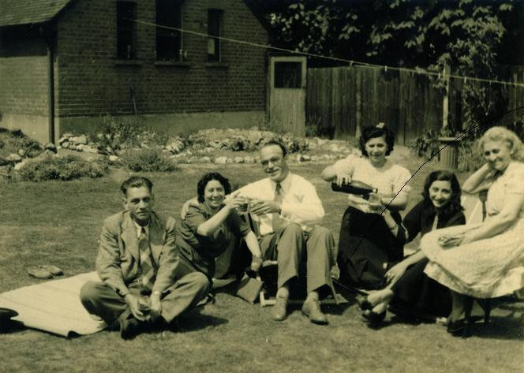
Grafton House, from left to right: Uncle Willie (Aunty Helen’s husband), Nana, Dad, Auntie Helen, Mum, Mer-Mer

Uncle Vaughan was old, too, but he was the one with the biggest - and youngest - family. They all lived in the large attic room on the top floor of Grafton House. He was married to Auntie Joan who was English and a whole generation younger than him; over the years they had six children, five boys and one girl, who were simply referred to as “the Bagram children”: Michael, Jackie, Jonny, Neil, Carl and Ricky (the last two were born after the Bagrams had moved out of Grafton House). The oldest child, Michael, was roughly my age. Uncle Vaughan was a sweet old man, small and slender, and kind and gentle. He drove an ice-cream van for a living, and when he came home in the late afternoon, he would treat us children to free ice-creams from his multi-coloured van which he would park on the front drive of the house. Those ice-creams, yellow slabs that came wrapped in paper, like butter, to be sandwiched between two thin wafers, were more delicious than anything I knew from Germany.

There were two more people, two young men in fact, living in Grafton House who, like the Bagram children, were my Mum’s cousins; one was Charlie, Mer-Mer’s son, the other was Kenny, Aunty Helen’s younger son. They both shared \a room on the top floor, next to Uncle Vaughan’s huge attic room; I do not remember seeing much of them, they seemed distant, wrapped up in their own lives.

There was, however, one other child who was at home in Grafton House, a girl not much younger than me; her name was Louisa, but everyone called her Lulu, and she was Aunty Helen’s granddaughter, and Kenny’s niece. She was the daughter of Aunty Helen’s other son, Norman, who had gone to Australia with his second wife and had started a new family there. For some reason Lulu’s mother Angela, Norman’s first wife, disappeared from the scene almost completely, so much so that it never occurred to me that Lulu even had a mother. Lulu ended up in the care of her grandmother, Aunty Helen; and her grandfather, Uncle Willie; but when Aunty Helen was in India, it was Nana and Mer-Mer who looked after her. Lulu and I used to play together, and Lulu had beautiful clothes and the most amazing toys, things I had never seen in Germany, like, for instance, the glamorous Barbie doll with all those different outfits, or the bright red sit-and-ride-scooter. Lulu was given all these attractive things by Aunty Helen.. I do not remember the Bagram children having many toys, apart from the odd toy cap gun, or cowboy hat. Lulu looked different to the rest of us, she was tall and blond and very pretty in an English roses-and-milk sort of way. Lulu had her bed and her toy corner in Aunty Helen’s and Uncle Willie’s bedroom on the first floor. Lulu seemed to be a lucky girl, living in Grafton House in the midst of this large family, but Mum often said that she felt very sorry for Lulu, pointing out the sad fact that she had actually been abandoned by both her parents.

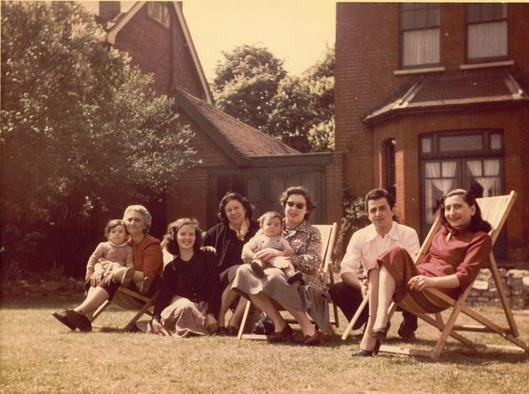
Grafton House, 1950s; from left to right: Mer-Mer with me, Aunty Joan, Nana, lady with baby unknown, Charlie, Mum

All in all, there were up to fourteen family members living in Grafton House, eight adults and up to six children, and with us there, we totalled seventeen people. But there was one other person around, a young man who did not belong to the family but worked for them. His name was Peter, and he was a Tibetan whom the family had brought along with them from India when he was a boy or very young man. Peter lived in a room on the top floor, next to Kenny and Charlie’s room and Uncle Vaughan’s huge attic room. Peter did not exactly take part in family life, and he and us children seemed to be the only ones who ever used that dusty old unheated outdoor toilet which was at the side of the house, next to the kitchen back door. Peter always seemed to be outdoors, somewhere in the large garden. I liked Peter because he was soft-spoken, cheerful and kind.

***
Calcutta

If the Bagram family had gone from rags to riches in a spectacularly short time, they seemed grateful enough for this change of fortune; they remained true to their roots and, taking nothing in life for granted, thanked their lucky stars by showing the world a cheerful, profoundly content and optimistic disposition, and by remaining compassionate and charitable towards the poor and the destitute – whose numbers, as an effect of British rule, were increasing at an alarming rate amongst Calcutta’s native Indian population.

The story might have ended here, if the three sisters, Mary, Elizabeth and Helen, and the two brothers, Sarkis and Vaughan, had all settled down into traditional lives, with straightforward solid marriages and children born in wedlock, and finally grandchildren and great-grandchildren in happy homes.( And if the family fortune had been handed down along the line equally, and fairly.) But as it happened, the only one out of the five to end up with a secure, timely and long- lasting marriage (to a respectable Englishman, no less), and with two sons properly born in wedlock, was Helen, who became Mrs Wilson (although, even here, there was a hiccup waiting to happen two decades down the line); Elizabeth never remarried after the loss of her husband and remained Mrs Khayat to the end of her days. Her older sister Mary, suffered a strangely similar fate. She, too, got married early in life (to a Filipino jazz musician), and she, too, lost her husband, if not through death, then by being abandoned. And she, too, never remarried (in fact, she did not even get officially divorced) and remained Mrs Mendoza for the rest of her life. Not only that, but each of these women was to bring up one child on her own, as a single mother. Not that that would have staged much of a problem, by then they could well afford large, beautiful homes and an army of Indian servants and ayahs to take care of the more mundane and tedious aspects of child rearing.

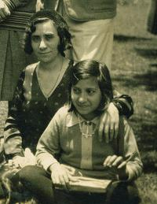

Mary Mendoza with her niece Gladys, Elizabeth’s daughter
India, 1920s

As for the brothers, Vaughan did not marry until many years later, when the family had moved to England, and Sarkis died young, in India, of some disease, presumably And a skeleton was hidden in the cupboard.

***

London

One of the major attractions of Grafton House was, of course, the television. In Darmstadt my only TV experience occurred when one of our neighbours, a young mother, occasionally let me join her young child in the early evening to watch Sandmännchen, a five-minute animated toddler show designed to put little children to sleep. Still, it was better than nothing.

But in Grafton House there was television galore. The TV was kept switched on non-stop, from the moment the broadcasting started until it ended and the test card appeared. Grafton House had two lounges, the “red lounge”, which was only used to receive formal visits and at Christmas,. and the large “television lounge”, where the family would sit with their dinner plates perched on their laps, or their cups of tea, and be entertained by whatever was being shown on that magic box.

Grafton House’s television set was encased in a polished wooden cabinet and had a prominent position in front of the large French windows leading into the garden. In the summer those French windows would be thrown open and you had to walk around this TV set to step into the garden; in the winter there would be an open coal fire blazing in the fire-place, and we children would sit as close to it as possible (this was before the days of fire-guards). Our place in the television lounge was on the thick soft wall-to-wall carpet, and we usually lay on our stomachs, close to the screen, chins resting in hands, eagerly absorbing every scene and every advert, believing every word. In this historic TV era of black-and-white fuzziness, we watched classic Hollywood movies, and lots of American TV westerns about Cowboys and Red Indians, shows like Bonanza, for instance, in which people spoke English with funny accents, and English things like The Adventures of Robin Hood, and Coronation Street, in which people also spoke English with funny accents; but the unforgettable signature tunes of those three TV events are permanently etched onto the hard drive of my memory. We watched children’s TV, Rin-Tin-Tin and Popeye the Sailor and Noddy and Mickey Mouse; we watched American comedy shows like I Love Lucy, and British variety shows like Sunday Night at the Palladium, anything that came on. But if television got boring, which sometimes it did when The News and the like was broadcast, we ran into the garden and played – preferably and predictably- Cowboys and Red Indians, shooting our noisy toy cap-guns at each other.

Mer-Mer was very superstitious about the television, and would become seriously agitated if anybody so much as suggested changing channels; she was convinced that turning the dial was unlucky and would damage the TV; so we remained firmly tuned in to ITV most of the time (as it happens, ITV, the first and only UK commercial channel in those days, was enjoying growing popularity at the time as ‘the people’s channel’).

Mum, of course, did not approve of this whole TV culture; she wanted to have conversations with people, be the centre of attention, talk about things. But in this case she simply could not beat the competition; however, my parents kept out of the television lounge, mostly, and they certainly were not to be seen balancing dinner plates on knees, absentmindedly shovelling food into their mouths; they insisted on sitting properly at the family’s dinner table (which was an up-side-down billiard table) in the large dining room. I don’t think anyone ever joined them there. Luckily I was allowed to have my food in the television lounge with the others.

The only TV show Mum really enjoyed watching was I Love Lucy. It made her laugh a lot.

Life in Grafton House was mainly characterized by the total absence of any rules or regulations or routines; everybody was free to follow their own inclinations or schedules. We children were free to run around and play all day long; nobody told us when to get up, when to eat, when to watch TV or when to go to bed; you went to bed when you were tired and you if you were hungry, you went to the kitchen and Mer-Mer would give you a plate of delicious dhal and rice, or meat-and-potato stew, or spaghetti. And in the mornings there would be wonderful breakfasts of bacon and eggs, and little bowls of crackling Kellogg’s Rice Krispies, and thin square slices of white bread toast spread with salty Anchor butter from New Zealand and Robertson’s jam which had the gollywog.

The other main attraction of Grafton House was the large garden. This was where most of the playing took place in the summer. The main part of the garden, stretching away from the house, was laid to lawn, and bordered on both sides by well-kept flower beds; on the lawn, by the house, the family had a large, luxuriously cushioned Hollywood swing, and we had endless fun madly clambering around on that swing. If it was hot and dry and the sprinklers were on, we would spend hours skipping and jumping through the water spray, while members of the family sat in the sun, relaxing in deck chairs, chatting and drinking cups of tea.

But by far the most interesting part of the garden was at the back where it abruptly took on a completely different character; at the end of the lawn, facing the house, there was a dense, impenetrable wall of greenery reaching across almost the whole width of the garden, and in the middle of this green ‘wall’ there was an opening in the shape of a pretty arch; the front of that arched entrance was decorated with two little stone pillars, one on each side, and for some reason these were always covered in black ants; the arch itself was like a green tunnel, covered in all sorts of climbers, which provided a walk-way to the very back of the garden; and once you arrived here, you were in a different world. Here everything was left to grow wild, the peach and the apple trees, the shrubbery, the gooseberry bushes, the knee-high grass, the waist-high weeds; it was like a miniature jungle just waiting to be explored by little children; and if that was not enough, in the far left hand corner sat an old, forgotten, derelict greenhouse, which had all sorts of interesting things growing and crawling in it; some of the roof’s glass panes had long ago fallen out and so rain water, quietly collecting on the floor and in old flower pots, had turned into stagnant green puddles; and if you looked closely, you could see little lizard-like creatures darting around in them. This was the perfect place for play adventure. Even if it meant the odd painful fall from some unsuccessful climb into the unforgiving thorns of the gooseberry bushes.

And so we played and had not a care in the world.

We played, more often than not, under the creative direction of my brother Richard; even though he was seven years older than me, and I was one of the older children amongst my cousins, he loved playing with us little ones and never seemed to run out of ideas. In the summer we turned large discarded cardboard boxes into foolproof hideaways, from which we cautiously peered out through little holes we had cut out, all of us huddling inside the box, sitting on old bricks, waiting for Mer-Mer to appear on the patio to call us into the house, enjoying the thought that she would not be able to find us, that we were invisible, undetectable. So we thought. And if Christmas time brought snow, we built massive fortresses and bombarded each other with cannon balls.

And so we played and time held no meaning.

***

Calcutta

Elizabeth kept her entire family under one roof. By the 1930s four children, three boys and a girl, were growing up in Elizabeth’s household, all of whom were being brought up by Sophie, now “Granny” and the three sisters; however, only the youngest one, Helen, had landed herself in a conventional life situation, allowing her to raise her two sons, Norman and Kenny in a lasting marriage to an Englishman. The other boy, Charlie, was raised by the oldest sister, Mary, later to become known as Mer-Mer. By now the family were residing in a large imposing mansion which even had its own servants’ quarters bordering the far end of the property.

Of those four children now growing up in Elizabeth’s family, Gladys, the only girl, was the oldest. Elizabeth generously and gladly financed the schooling of all four; the three boys, Norman, Kenny, and Charlie, were sent to St.Paul’s School, a British, high-reputation all boys’ public boarding school in Darjeeling in the Himalayas, and she decided to send her daughter Gladys to a rather exclusive and renowned convent school, also in the Himalayas. St. Helen’s Convent was situated in the high altitude of Kurseong, just 30km from Darjeeling, the place which had been established by the British colonialists as a popular summer retreat for British officers and for rich white Calcutta residents. St. Helen’s Convent, picturesquely nestling against a steep mountain side, was run by British Roman-Catholic nuns for predominantly British children of high-ranking officers or of generally very wealthy and influential parents.

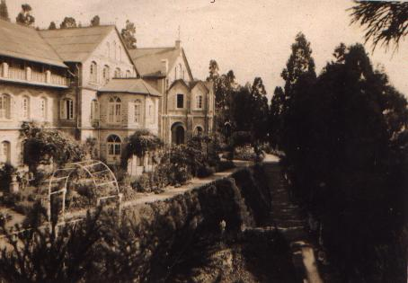
A 1930s photo of St. Helen’s Convent, Kurseong

***

London

My experience of Grafton House was, of course, inextricably linked to the experience of being in England, or rather, in London. I would often be taken along by Mer-Mer or Aunty Helen to the local shops to buy the groceries. The walk took you along quiet, sedate St .Mary’s Avenue with its lovely houses and beautiful large chestnut trees towards Wanstead Tube Station on the right, and The Green towards the left, a huge expanse of grass land, dotted with large trees, park benches, and paved walks cutting diagonally across it; beyond this you crossed a busy street and you found yourself in a row of little shops. The butcher’s was the strangest of all; for some reason that I could not figure out the tiled floor in the butcher’s shop was always thickly covered in woodchip, the smell of which mingled oddly and unforgettably with the smell of fresh meat.

But everywhere we went I heard friendly, kind, chirpy voices, instead of the stern barks I was used to from Germany, and the shopkeepers said incredible things to Mer-Mer or Aunty Helen when addressing them, “Will that be all, love?”, or “That’ll be three and six, sweetheart”. It made you feel all warm and safe inside. Perhaps they were the same people who painted their houses the colour of sweets. Speaking of which, surely English sweets had to be the best in the world; the little newsagent’s at the tube station sold them, all sorts of tubes and little packets, all perfectly lined up in neat little rows, bursting with colour; Spangles and Polo mints with the hole in the middle, and Rowntree’s Fruit Gums, and Rowntree’s Fruit Pastilles; Milkybars, made of strange white chocolate, Treats, chocolate-covered peanuts which “melt in your mouth not in your hands” as the TV adverts pronounced; Cadbury’s chocolate bars, and Kit Kat and Wrigley’s Spearmint chewing gum, and pink and white squidgy marshmallows; and of course, multi-coloured Smarties in little circular tubes with colourful collectable plastic caps; and little packets of crisps, each of which contained a tiny sachet of salt which you had to sprinkle on; and boxed chocolates called Black Magic which were my Mum’s favourites.

Sometimes Mer-Mer or Aunty Helen would take me to the playground situated in a park behind the shops, and which you got to by walking along a narrow little alleyway; this English playground was so much more interesting than the German ones back home; it had long swings which let you swing really high, and even special short swings with box seats for small toddlers, and everything was painted in red and green and blue; best of all was the slide; an enormously high structure, it took ages to climb up those steps, but what fun when you got to the top!

Such was my little window into the world called England, or rather London, and I loved every bit of it.

One sunny afternoon Nana took me out with her in her little black car; she needed to go somewhere or other but she got lost and finally stopped the car in some quiet residential area and asked a passer-by, a rather strange looking man, for directions; he was friendly enough to answer her questions, and she started chatting to him, mentioning that I was her grandchild from Germany. In an instant the man changed; all friendliness gone, and the sun disappeared behind a cloud. He stared at me coldly, and with shocking hostility in his voice declared that he was a Jew and that he absolutely hated the Germans, all Germans, because of what they had done to his family. He went on talking to me, all the while fixating me with his strange, unfriendly glare; and I glimpsed something then, not sure what; but Nana, sitting behind the wheel next to me, listened to the man quietly and intently, with an air of particular concentration; she seemed pleased almost, silently willing me to pay careful attention; it was as if she was talking to me with her mind, you see this man who is a Jew? You hear what he is saying? The sun came out again, and I see him standing there, in the sunshine, telling little six or seven year old me serious, complicated things, and I simply did not understand them, but I did understand that he had a reason to be distinctly unfriendly to me. There was an intensity about the whole situation that burnt itself permanently into my memory

I liked spending time with Nana, and I was often in her large bedroom where she would be pottering about quietly, while I would look at the many old family photographs which had been stuck under the large glass pane of her dressing table, or at the large framed studio photographs of Richard and me as babies and toddlers hanging there on her wall. Being with Nana felt good, and easy, there was no need to talk, things communicated themselves without words. Sometimes she would become very pensive, then she would say, “Come, dalling [her way of pronouncing ‘darling’], let’s go to church and burn candle”, and so together we made our way to the church, walked down the aisle to the front, and up to the table with the burning candles, and Nana would pick up a fresh candle, light it and place it solemnly amongst the others; we would watch the candle burning for a while and then quietly go home.

Every so often, when there was a need for more extensive shopping, the family would pile into cars and travel to Leytonstone where there were big shops and department stores. Most garments were bought at Marks & Spencer’s which never ceased to be a great favourite with Nana and Mer-Mer, it offered solid, long-lasting quality at reasonable prices, and Mum loved shopping there, too, and as to the children’s department, I was usually stunned by the sheer prettiness and sparkle of it all, the bright pinks, the frills, the fluffiness, they even sold tiny plastic handbags and, unbelievably, things like lipstick and nail polish, and ever so pretty fashion jewellery for little girls. We had none of this in Germany.

The family’s other favourite department store was called Bearman’s (it no longer exists) and apparently Nana became rather notorious in this particular establishment; stories were told by the family of the things Nana could get away with there: buying an expensive carpet, for instance, and after several weeks changing her mind and taking it back to Bearman’s - who would immediately give her the full refund, without so much as a word of protest.

Yet nothing could beat a London toy department, of course. Dolls and toys so unbelievably advanced, from America, probably, it was to take years and the end of my childhood for any of those things to turn up in German toy shops. But there were also the large thick colouring books and the fantastically panned out rainbow sets of colouring pencils, and interesting puzzle books, and a thing called ‘Colouring by Numbers’, a drawing template which came with an array of tiny pots of paint, of exactly the required colours. And comic books. In English. The Flintstones and Superman, memories of these so vivid, hard to tell whether their characteristic images flashed across the television screen in Grafton House as well or whether they were simply animated by my mind’s imagination.

All of these impressions served to create a fatal link in my mind, a welding together of images and emotions which made me wholeheartedly embrace with a child’s love and admiration not only Grafton House but London, and not only London but England. Little did I know then that neither London, nor England, loved me back.

