Chapter 4

Darmstadt

The years at the Darmstadt primary school Wilhelm-Leuschner-Schule did not make much of an impression on my memory, probably because things ran smoothly in that area. I generally enjoyed school and conscientiously did my homework. But every so often, and more and more frequently, a new pupil would join our class, and each time the new class member would be introduced by the teacher with an air of awe and importance; and we understood that their presence amongst our midst was due to their families having survived a dangerous and heroic adventure; they had successfully escaped from East Germany, had bravely taken on ‘The Wall’, that terrible, heavily guarded wall which was dividing Germany, and had by hair’s breadth escaped the horrendous fate of being shot dead. We were duly impressed by this, and were only too happy to spend time in class preparing care parcels, shoe boxes filled with charity, for our poor brothers and sisters trapped in East Germany. There was something horrible going on, and the grown-ups were shaking their heads in helpless dismay.

One day, when I was about eight or nine, we had one of the regularly occurring visits from the school doctor, and so each class had to leave their lessons at some point during the morning and, in alphabetical order and stripped to the waist, had to file into the school hall to be given a general health check. A few days after this, my parents were informed that the school doctor had found me too thin and too pale and had given me a prescription for a six-weeks stay in a children’s sanatorium (Erholungsheim) to improve my health. The sanatorium was situated on Borkum, one of the little East Friesean islands off the coast of the North Sea, an area renowned for the highly beneficial quality of its sea air. Since I was doing well at school, there were no concerns that I would be missing six weeks of lessons, and so my parents agreed for me to be sent away that autumn.

Those six weeks turned into a dream. It began with my parents taking me to the train station, where dozens of girls with suitcases were already assembled, waiting restlessly with their mums and dads. We joined this crowd, and Mum started talking to me rather nervously, reminding me of this and that, urging me to write regularly. And heads turned. The heads looked Mum and me up and down. More heads turned. And I experienced a new feeling. That of such intense embarrassment that I wished I was invisible. I saw then how Mum stood out from that crowd, with her expensive fashionable fur coat and jingly bangles and her dainty shoes and slim elegant legs. With her expressive gestures and her uninhibited voice, sounding too loud to me. Speaking in the wrong bloody language. Looking around, I saw the other mums, sturdy, no-nonsense women in sensible footwear and Germanic overcoats, frowning disapprovingly in our direction. I looked back at them, longingly. And I felt ashamed of my Mum. I so wished then that I had a normal average German mum, like everybody else. I wanted to live comfortably in the crowd, not be dragged out of it. Mum knew instantly and I saw the hurt and disappointment in her eyes when I shied away from her embraces and kisses as the train arrived and everybody started to say their goodbyes. I boarded the train, clutching my suitcase, feeling vulnerable and insecure, but no, not sad.

Dreamlike memories. It did not really sink in, that I was now on my own, thrown in with a crowd of strange children, sitting closely packed with five others in a six-seat train compartment, eating my packed lunch and fitfully dozing off to sleep as the hours went by. But at least now I blended in alright, and the other girls seemed friendly enough.

Borkum

The holiday home was a huge three-storey building situated next to the wide expanse of the island’s beaches which pan out into the famous North Sea mud flats. We slept in large dormitories and ate our meals in an immense dining hall, sitting close together on benches along long rows of closely set tables; there were several hundred girls staying there at the time, many of them were older, but none significantly younger; I belonged into the youngest age group.

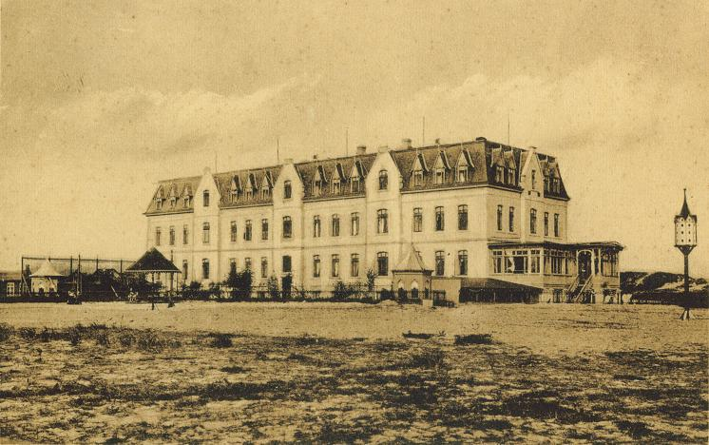
Borkum

Being out in the fresh sea air and eating plenty of food were the main points on the agenda, and so we spent a lot of time on walks along the beaches and into the mud flats, and the all-female staff of the home made sure we ate well at meal times; they would walk down the aisles and carefully inspect every child’s plate at the end of each meal. Actually, we had no choice here. The iron rule was that you had to finish your portion of food; if you did not, you were made to sit in front of your plate, supervised by two dinner women, until you ate everything up. This could turn into quite an ordeal. Every so often, when I crossed the dining hall in the late afternoon, to get to the staircase leading to the dormitories and toilets, I would see a distraught girl or two still sitting in front of her now long cold lunch, tears streaming down her face, gagging and desperately trying not to vomit, while two women were standing over her, intent on winning this unwholesome battle of the wills.

So meal times could threaten to become a worry, luckily, however, I did not have too many problems with the food. Breakfast usually consisted of thick, rather slimy but edible porridge, and a cup of milky malt coffee, and lunch would be a cooked meal of meat, potatoes and a vegetable, or a hot pot. In the evenings we had rye bread with slices of sausage or cheese, and some red, herbal tea.

But there was one lunchtime meal that sent shivers of horror down my spine, and could have seen me as the one crying and gagging through the afternoon, had it not been for sheer luck. Set in front of us was the most revolting thing I had ever encountered, two large thick slices of fried Blutwurst (‘blood sausage’, black pudding), dotted with great big lumps of white fat. Just the smell and look of it made me feel sick. The first time this meal was served I felt real panic, I knew I would not be able to hold even one little bite of that vile stuff in my stomach; and the dinner women were already beginning to march down the aisles. Desperate now, I quickly asked around at my end of the table if anybody would care to have my portion of Blutwurst, and incredibly, a girl two seats down the line happily offered to have my slices as this was her favourite food. Quickly, and just in time, I transferred the horrid sausage to her plate, and when the dinner woman arrived at my place, I was happily and heartily finishing off the mashed potatoes and vegetables which went with this meal. To my great relief I got away with this every time Blutwurst was on the menu.

Then, one day, another horror threatened. It presented itself in the shape of a few girls, sitting red-eyed and snivelling in the dining hall, their heads wrapped in towel turbans and a strange strong smell surrounding them. These girls, we learned, had been disgraced by the fact that they had been found with head lice, and in such cases the home, without much ado, took immediate action; the girls’ heads had been completely shaven, and a certain, strong smelling ointment had been applied. I remember one very pretty girl, who had had very long, blond hair, being completely devastated by this; and she was terribly worried what her parents would say when they found out what had been done to her. And again, I was lucky, no head lice invaded my hair.

As for contact with home, our first letter, or was it a postcard, to be sent to our parents was dictated to us word for word on arrival, after we had been assembled in the large dining-hall; those letters were then collected and posted by the staff; I wondered what Mum would think, reading my uncharacteristic German which simply said that I had arrived and that everything was fine. After that, we had regular letter writing sessions, but the staff read each letter carefully and made sure that we wrote nothing but pleasant and meaningless things about our stay in the home. And they did not allow letters in English. But at least they handed out our post from home unopened. I did not get many letters, though.

As it happened, my birthday fell within these six weeks on Borkum, and the home allowed for the birthday child to have a small party with her age group, as long as the parents sent sufficient party snacks, addressed to the staff, which could be shared out evenly amongst the group. My parents, of course, sent a large parcel full of goodies, and as a special treat, added several packets of marsh mellows and a box of Black Magic chocolates which they had brought back from England that summer and which you could not buy in Germany. Two staff members organised the little party, we had a game or two, and a song or two, and then the sweets from my parents’ parcel were brought in and equally shared out. I was happy, and since I did not know what my parents had put in that parcel, I did not notice what was missing; neither marsh mellows nor Black Magic chocolates were handed out to any of us.

They were quite strict at that home, and they did not put up with any nonsense or unruly behaviour, and so we hardly dared break any of the many rules regulating the daily routines. But some rules were difficult to follow, as, for instance, the ones concerning the bedtime routine. There were about eight to ten beds in my dormitory, and in order to prevent us from chatting to each other at bed time, each of us was told which side of the room we had to face while going to sleep. My bed was placed against a wall, and so I had to go to sleep on my left side, facing the wall. Which I did. But it happened now and again that just before or after falling asleep I unconsciously tossed to my right side, ending up facing the room. A staff member would immediately shake me awake and order me to turn back on my left side. And even at night, when we were all fast asleep, staff would be patrolling the dormitories and anybody found sleeping on the wrong side, facing the room, would be woken up and ordered to turn around. I found it almost impossible to remain lying on one side all night long, This was clearly beyond my control, yet I ended up feeling guilty and helpless, and I hated the unfriendly roughness with which they kept waking me up.

Time crawled slowly, the weeks stretched maliciously, with no end in sight. And at night, facing the wall, I missed Mum so much that it hurt. I cried then, and thinking of Grafton House made me cry even more.

But finally, against all odds, the last day did arrive, and we were taken to a souvenir shop on the beach to spend our pocket money. There I bought a little wooden box for Mum; it had a lid covered in pretty sea shells, and for Dad I chose a large shell shaped like a cone. The shop owner, a kind and friendly lady, smiled encouragingly at me as I was carefully choosing and proudly buying presents for my parents all on my own.

That night I went to bed for the last time in that house, so relieved that it was all over and excited about the next day’s journey home to Mum and Dad. But it was not over yet. Not quite. That night I was shaken awake out of deep sleep by two very angry staff women. They ordered me to pick up my packed suitcase and other things, grabbed my bedding and, without further explanation, marched me out of the dormitory. I was led into the sick room, a small room with only one bed in it; my bedding was thrown onto this bed and I was sternly told to go back to sleep, then they left the room, slamming the door shut behind them. I lay awake for the rest of the night, trying to work out what on earth had happened. Why had they woken me up? Why were they so angry with me? Why did I have to be in the sick room all on my own? And why did no one tell me anything? I tried to console myself with the thought that I would be on my way home the next day, but there was now a nagging worry in my mind, growing into a creepy, panicky fear: what if they did not let me go home tomorrow? But the next morning another unfriendly woman opened the door and ordered me to join the others with my luggage. I was going home after all. And yet. The me that was leaving was not the same me that had arrived. Something felt broken.

The dream that was Borkum did not end until I found myself standing in my room, surrounded by my beaming parents, looking at a large box shape covered with a cloth. This was my surprise birthday present, and when Mum lifted the cloth with a dramatic gesture I found myself looking into the black beady eyes of two sweet little budgies, perching close together on a rod in their cage. Suddenly, and without warning, tears sprang into my eyes.

The stay had been successful in that I had put on quite a bit weight. However, after a few weeks of enjoying Mum’s hearty cooking I was back to my usual thin self. Funny that. I loved my food at home and I ate as much as I liked, yet remained thin. But the Borkum diet had made me put on weight.

Mum was really furious when she heard about the marsh mellows and Black Magic chocolates, though.

***

Kurseong

St. Helen’s Convent ran uninterrupted for nine months, from the end of February until early December, with one single three-month holiday break over Christmas. The train journey from Calcutta to Kurseong, situated in Darjeeling district, was a long one, but the last part of the voyage involved changing trains at Siliguri, and had to be travelled on the Darjeeling Himalayan Railway, in a tiny 60cm narrow-gauge steam-powered train that laboriously puffed and chugged its way up the steep mountain sides, covering 86 km in 8 to 10 hours, climbing to an altitude of 2,200m. It was nicknamed the Toy Train, and became famous not only as a significant engineering feat, but also for the breathtaking beauty of its scenic route, with views on the peaks of Himalaya giants such as the second highest mountain Kanchenjungha (8591m); however, Gladys always intensely disliked this part of the journey because the extreme changes in altitude invariably gave her heavy nose bleeds.


The Darjeeling Toy Train

The Congregation of the Daughters of the Cross, founded in 1833 in Liege, as a congregation of the Catholic Church, saw her daughters from England arrive in Kurseong in 1890. In the same year the foundation stone for St. Helen’s Convent was laid, but it was not until 1900 that the British nuns and their pupils moved into their final and permanent school building. It has been recorded that choosing a suitable property and building the school on it had been no easy task:.

“But to build a large Boarding School on a shapeless rocky mountain, was an appalling task. The whole mountain side had to be cut and borne away, and blasting of the hard rocks had to be resorted to, continually. All the heavy iron material had to be brought from Calcutta, 400 miles away. Mother Marie proved equal to every occasion, and, in February 1900, the Sisters made their entrance into St. Helen's at Caledonia. Consequently the School doors were opened on the 19th February 1900, to the overjoyed pupils and teachers, with Sister Marie Aimee as the new Superior” .[From the web pages of the present-day school, now called St. Helen’s Secondary School, Kurseong, under the management of the Daughters of the Cross]

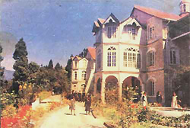
Contemporary photo from St. Helen’s website

And so it was that, thanks to her mother Elizabeth’s fortune and generosity, Gladys was to spend her entire school days in these gentle, serene and spiritual surroundings, in this favourable mild climate and in this breathtaking landscape of towering snow-capped Himalayan mountains high above and of green lush valleys far below, in this world of dramatic skies and unforgettable sunsets.

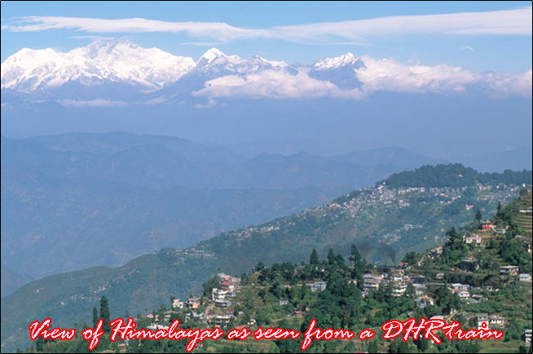
View of the Himalayas from the Darjeeling Toy Train

Gladys did not have possession of nor did she ever see her birth certificate, and she remained unsure as to the exact year of her birth; but one must ask oneself why her mother, Elizabeth, did not keep record of these things. Illiteracy might explain a nonchalant attitude towards written matter; on the other hand, perhaps she was simply not in the habit of memorizing time by numbers of years, although there did not seem to be any doubt that Gladys’s day of birth fell on the 16th of September, as did, by sheer coincidence, that of her Aunt Helen. In the end, Gladys settled for the year 1920, to be recorded in her passport and other certificates.

And there was another oddity. Gladys never found out why she was registered at the school under the name of Gladys Bennett, and not as Gladys Khayat.

Gladys spent a minimum of ten years at St. Helen’s Convent, sometime between the years 1926/27 and 1937/38. Looking back, she would talk fondly of the school, the nuns, the other pupils, the hills, and the sunsets. She embraced the tranquillity and high-spirituality of convent life wholeheartedly, so much so that she wanted nothing more than to grow up to become a nun herself. Far removed from the vulgarities of the outside world for nine whole months, and under firm but gentle guidance from the nuns, she refined the delicate, sensitive and graceful aspects of her nature and the compassionate and generous side of her character.

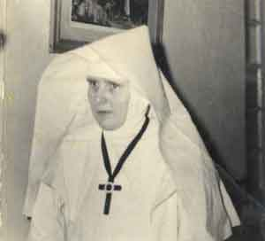
A nun from St. Helen’s Convent

But there is more, much more, to the thin clear air of high Kurseong where gentle rains fall and orchids and tea gardens thrive in misty valleys and hillsides. The majestic world of the Himalayas - ‘rooftop of the world’, no less,- breathes Buddhism all around. Materializing in the form of Tibetan monks with their shaven heads and their orange-red robes. And their monasteries. And their spiritual chanting.

The truth is: the British nuns, in their white, stern, starched habits, and for all their sincere and deeply spiritual Christian goodwill, did not really, not historically, not culturally, belong. Presumably Buddhist monks were not in the habit of hacking chunks out of mountains for their abodes. Presumably, they built their monasteries in places that offered themselves naturally, organically, as places for spiritual contemplation and enlightenment. The people of these regions lived not only in high altitude, but also on a high mental and spiritual plain.

There was a series of minor events which prevented Gladys from pursuing that laudable path which would have led her to the life of a Catholic nun.

***
Darmstadt

One time we had a rather more spectacular visit from Mum’s family. In front of the entrance to our little block of flats was parked a tiny camper bus, and out came a surprising number of people: Nana, Mer-Mer, Uncle Vaughan, and Richard. They stayed for a couple of nights, sleeping on sofas and makeshift beds on the floor, and then, leaving Richard behind with us, continued their journey to Tehran, Persia, to visit some distant relatives. It seems to have been mainly Mer-Mer who wanted to return to the country of her birth, after 40 or 50 odd years. By a strange coincidence, Persia happened to make news headlines just as Nana, Mer-Mer and Uncle Vaughan arrived there. The country was hit by a devastating earthquake, killing thousands. For days Mum was pacing up and down the flat with worry. As it turned out, the family had escaped the earthquake, and were safe and sound. (This must have been the Buiyn-Zara Earthquake, which had a magnitude of 7.5, a death toll of 12.200, and its epicentre 150km southwest of Tehran. it struck on September 1st 1962.)

And by another strange coincidence, Persia was to play yet another role in our lives. This time the link was made by my Dad, who was sent to Tehran to oversee an important exhibition which his company, Modag/Demag was staging to present and advertise their products (diesel engines, I think). The opening of this exhibition was graced by the presence of Reza Pahlavi, the Shah of Persia, himself, and my Dad even got to shake hands with the Shah. This event was, of course, photographed, and Dad proudly showed this picture to everybody back home. Sadly, however, this photo seems to have become lost.

Mum was very excited by my Dad’s contact with Persia, as it meant the chance of getting hold of the world’s best long-grain rice, and of some Persian sweet which, indeed, was extraordinarily delicious; it consisted of small round slabs of a white, soft substance, densely packed with strange but extremely tasty greenish nuts, and generously dusted with a fine powder of icing sugar. Those nuts, I learned, were called pistachios, and they were unheard of in Germany; pistachios they were also sold roasted and salted in their split shells. Dad duly brought all these things home for us, and we had a feast. And for weeks after that, Mum made the most wonderful fragrant pilau of those super long grains of Persian rice.

And then, one day, we actually had a visit from a family living in Tehran, Persia, or Iran, as it was beginning to be called. Elsie, who was in some way related to Mum, and her husband stayed with us for a few days, and I made friends with their daughter Diana who was my age. They were lovely people, and they looked very foreign with their jet black hair and dark eyes. Mum thoroughly enjoyed their company, and so did I. Diana even tried to teach me how to write in Persian, and I learnt that the Persians write from right to left, and that Persian books begin at the back.

And there was to be yet another link to Persia. Some time after the family’s journey to Persia Mum’s cousin Charlie, Mer-Mer’s son, visited us with his new wife. Armik was a very distantly related Armenian from Tehran, and the really strange part of this story is that Nana and Mer-Mer actually arranged this marriage for Charlie and that he was happy to agree to it. When Armik left Tehran for good and arrived in London a few weeks prior to the wedding, she and Charlie met for the very first time, having known each other until then only from photographs and letters. Armik was not only an extremely beautiful creature, she was also sweet-natured, intelligent, and charmingly shy. We all fell in love with Armik. Their marriage was to last to this day.

There is no clarity in my memory as to the sequence of events as they shaped the years in Orangerieallee, which came first, which later, hard to tell. There was only one incident of which I know the exact date because it was my Dad’s fiftieth birthday (he was born in 1912). That morning there had been a big and rather merry celebration for him at the office, and he came home at lunch time, having the rest of the day off. This was the first and only time that I saw my Dad really drunk. He swayed into the lounge, in the very best of spirits, holding in one hand a bottle of wine or champagne and triumphantly singing “hey-barbariba-barbariba hey..”, a well-known line from a popular tune going back to the 1940s. He was extremely funny, so drunk and out of control, and it made Mum and me laugh tears.

Even though my parents did not go nightclubbing any longer, they still had a lot of fun, and they enjoyed hosting small parties at home. On these occasions our flat would look its festive best, Mum would take a lot of time dressing up and putting on her make-up, Dad would busy himself behind “the bar”, studying his latest cocktail recipes, and I would be allowed to set out the little Indian brass bowls filled with salted peanuts, pretzels, olives, and cheese biscuits, not without having the odd little nibble, of course. I would be around when the guests arrived, politely curtseying while shaking their hands, but shortly after that I would go to bed and sleep soundly through the night.

What happened at those parties can be deduced from photographs and from my parents’ comments the following day. One thing is clear; everyone got pretty drunk, and the partying went on until about two or three in the morning. Towards the end my
Dad would go to the kitchen and brew some extremely strong filter coffee to quickly sober up those guests who had to drive.

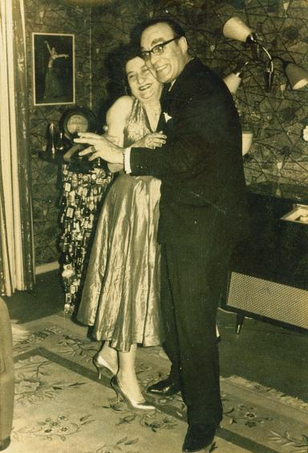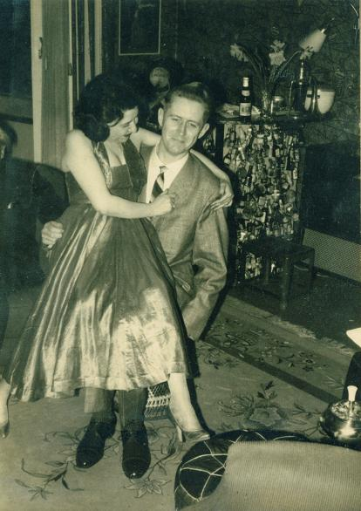

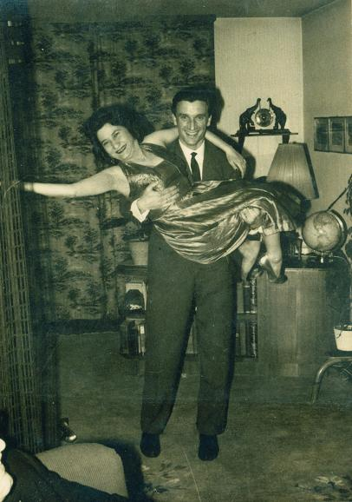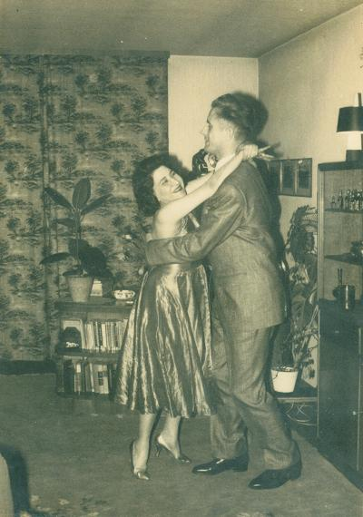

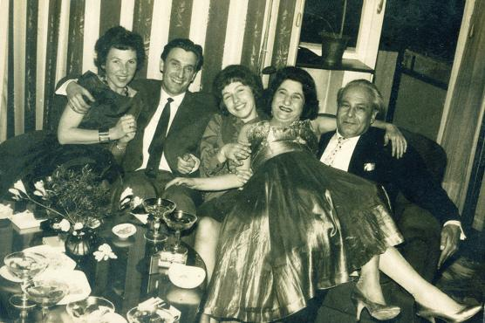

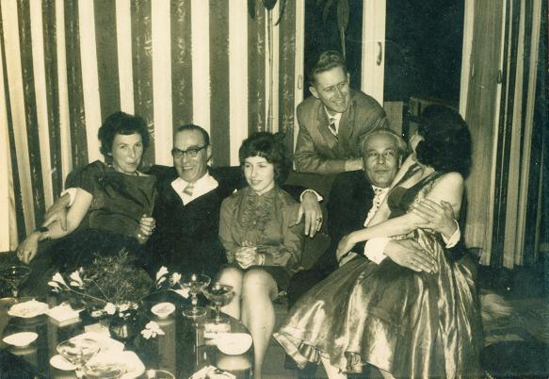
party time in Orangerieallee, early 1960s

I look at the photos of those happy parties with keen interest but something strikes me at not quite right. Something that I cannot put into words. Something that should not be there. Dad with his arms around two women, laughing at the camera and I do not like the expression on his face. Mum ostentatiously kissing one of the male guests. Looking graceless and silly and her flashy party dress seems wrong and out of place. Oh, it was all in good spirit, of course. Perfectly harmless. And yet.

There was something else that used to make me feel intensely uncomfortable, a form of grown-up entertainment that was, and always would be, totally alien to me. My parents adored telling so-called dirty jokes. Sometimes they would tell them to each other in front of me, and of course I did not understand them, but I really, really hated the way they laughed then, with that unpleasant undertone. It sounded and felt wrong.

As for jokes, Mum took intense delight in one particular manifestation of a practical joke. It consisted of a piece of rubber which was made to look like sick, very realistically, with little pinkish grey bits in it. So, sometimes, when Mum had a couple of her German neighbours over for coffee, she would launch into her ‘act’, and she was brilliant at it. It went like this:

Scene 1: Mum is chatting animatedly to her friends.
Scene 2: she suddenly halts in mid-sentence, frowns, and mumbles something about not feeling too good.
Scene 3: she carries on chatting happily.
Scene 4: she halts again in mid-sentence, but now with more drama, and informs her friends that she is really feeling quite bad.
Scene 5: she is chatting again, but then suddenly makes a strong vomiting noise and throws up – that is, she swiftly throws the rubber sick, which she has previously moistened with water for more realistic effect and she has kept hidden under a cushion next to her, onto the carpet in front of her.
Scene 6: she gleefully watches the result of her act, as her friends look intensely embarrassed, shocked, and at a loss as to how to deal with the situation.
Scene 7: she apologizes profoundly and looks completely stricken and embarrassed herself.
And in Scene 8: she acts out the grand finale. She quickly bends down, picks up the rubber sick – and throws it at one of her friends who then screeches with shock.
Denouement: everybody realizes that this was a joke and laughs. But the greatest joke was that Mum acted so believably that she fooled people every time.

We were a happy family, and a posh one, too. We had special cutlery for eating fish and special knives and dishes for our butter and we kept a variety of jams in special lidded jars with their own spoons, we had linen napkins placed in thick silver rings, and we sat nicely at the dinner table and Mum put the food in special serving dishes with special serving spoons. Dad tended to criticize our table manners, though. According to German etiquette a potato was to be broken into bite-size pieces by the fork and never, ever touched by the knife; and the food was to be placed on the fork and carried to the mouth in the manner of a shovel. But Mum did not change her English habits. She merrily sliced through potatoes and rarely used the fork like a shovel; instead, she held the fork the other way around, using it like a spike and daintily balancing morsels of food on its arched back. She told me a story once about a spy who pretended to be American but he got found out when he finished a meal and placed his knife on fork the wrong way on his plate. This whole table manner issue was confusing and I did not know who to follow. I became so self-conscious about it that I eventually refused to go on class trips, frightened that I would not know how to behave properly at the dinner table.

But a happy family we were, and financially well off, too. We lived in a lovely flat, we ate only top quality food, and we went on holiday regularly, even it was always Grafton House. Once, however, my parents took me on a different holiday, this time to Switzerland to visit some friends there. We travelled by car, and on our way we stopped at Überlingen at Lake Constance (Bodensee) where we stayed with Lilo and Gerry Pfeiffer. Lake Constance lies on the border between Germany, Austria, and Switzerland. It was spring, the air warm, the sun shining in a cloudless sky, spring flowers everywhere. This was happiness, strolling along the lakeside, among the busy crowd of holidaymakers, holding Mum’s hand, both of us wearing a spring dress made from the same floral pattern material, watching the white ferries and sailing boats criss-crossing the vast lake..

One evening Lilo and Gerry made a most unusual meal for us; it was called fondue; on the table, on a burner, sat a pot full of boiling oil, and you had to spike pieces of raw meat on special long-handled forks and fry it in the oil; along with this went fresh baguette and an assortment of garnishes, dips and pickles. My parents were most impressed, wrote down the recipes for the garnishes, and decided to invest in a fondue set.

Then one afternoon Gerry took me to a bookshop and bought me a special book called ‘Was blüht denn da?’(What is that flowering over there?) It was a kind of picture encyclopaedia of all the local wildflowers; we then took a walk through a little forest and Gerry pointed out the various flowers growing in the undergrowth, and I looked them up in the book, and learnt their names.

After a few days we left and drove to Basel. But something had happened. In the car, my parents kept talking agitatedly about Lilo and Gerry, discussing over and over who had said or done what. We never saw them again. But henceforth fondue was on Mum’s menu as a meal for special occasions.

In Basel we stayed with Lorna Wipf and her husband; they had a son who was a few years older than me. They lived in a quiet residential area and because it was warm and sunny, I spent a lot of time playing outside. This road was probably all I saw of Basel, but it had a very unique quality about it; it was like being in a different altitude. The houses in this road were mainly white bungalows, with pretty front gardens, all cleanliness and purity and tranquillity, it was – peaceful, and the sun smiled.

Lorna was a friend of Mum’s, they had met on the ocean liner which brought them both to Europe to start their new lives, Lorna with her Swiss, and Mum with her German husband. Lorna was Anglo-Indian, and very keen on status symbols. One of these sat in her bungalow and impressed Mum no end. It was a large white chest with a heavy lid – a freezer, the latest thing that had hit the market. Lorna explained all the advantages and techniques of freezing (labelling and dating plastic airtight containers) and it took little to convince Mum that this was, indeed, a brilliant idea. We went home and bought a freezer. We never saw Lorna and her family again, but Mum kept in touch with her over the years. The last I heard was that their son committed suicide when he was about seventeen

Apropos Switzerland. Nana always said that when I had completed my normal schooling, she wanted to send me to an expensive and exclusive ‘finishing school’ in Switzerland for a year, where I would learn how to be a proper ‘lady’, things like etiquette and protocol and how to move and behave in high society. And table manners. It never happened, though.

