Chapter 5

When Gladys, probably at the age of about six, began her school life at St. Helen’s Convent, a beautiful and talented thirteen year old girl was spending her school years at another Roman-Catholic convent, only this one, called the Convent of the Sacred Heart, was thousands of miles away, in Roehampton, England. This particular girl had been born in Darjeeling on 5 November 1913, under a lucky star, it was said, for her mother, a strict Catholic, had faced the Himalayan giant Kanchenjungha just before giving birth. The girl’s father was English, and some people in Calcutta, where this family lived for a number of years, said that her Irish mother had Armenian blood. This particular girl displayed a great talent for acting very early in life, and she performed regularly in school plays. She was to become world famous as Vivien Leigh.

When Gladys was eight or nine years old, she fell into a coma. She was at school in Kurseong at the time, and the nuns, unable to determine the cause of this strange and frightening sickness, prayed day and night. When Gladys finally recovered, she was left with a lifelong intense aversion against cow’s milk.

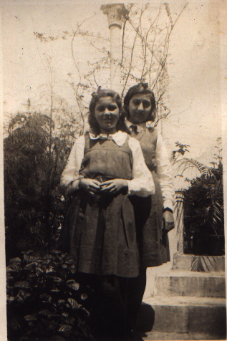

St. Helen’s Convent, Kurseong
Gladys (on the right) with a school friend

At about the same time, in 1929, just 30 km away to the north, in Darjeeling, nineteen-year old Agnes Gonxha Bojahiu began her novitiate, preparing her for the life as a Roman Catholic nun, walking the path that would lead her to become known the world over as Mother Teresa. She took her first religious vows as a nun in May 1931.

It seems that one of the main reasons why Gladys eventually changed her mind about pursuing the life of a Roman Catholic nun lay in an experience that made a deep impression on her mind. The area around Kurseong was hit by an earthquake, not an unusual occurrence in those regions, the ground shook, the walls threatened to cave in. The panic stricken nuns quickly herded the entire school into the convent’s chapel, and ordered the frightened girls to kneel and pray for deliverance. Gladys, however, felt an insuppressible instinctive urge to run into the open - away from walls and roofs. Perhaps this was, indeed, a test of faith - which path promised survival: praying in an enclosed building or running free of the shaking walls? Gladys decided for herself then that running free would be the more promising, and the more natural option. In nearby Darjeeling, that same earthquake may well also have been felt by Agnes Gonxha Bojahiu and the nuns who were instructing her, yet the earth’s shaking, whether then or at any other time, was not likely to impact in any way on their faith. But in Kurseong, for sure, the question of right or wrong conduct during an earthquake remained unresolved, for the walls of the school and the chapel stood their ground, and no one was hurt.

Having shaken off the constraints of Roman Catholic theological thinking, Gladys soon found her true passion and, so it seems, true gift in life: she was born, she discovered, not to be a nun, but to be an actress. Forthwith she was on the stage at every opportunity, delivering pleasing and convincing performances in every school drama. But it was not vanity or the promise of glamour that motivated her, she was not the beauty queen type of person, and she did not perceive herself as being in any way pretty, in fact, she even thought that in some ways she was rather ugly, not least due to the squint in her eyes. No, her interest lay in conveying character and the deeper layers of motive and emotion

As to her looks, she was certainly very attractive, if not beautiful in the classic sense.

***

Darmstadt

Those happy, sunny days in Orangerieallee. Occasionally, though, I would wake up at night and feel frightened; I could hear the sound of distant gunshots out in the black night, and in such cases I would go to my parents’ bedroom and climb into Mum’s reassuringly warm bed and go back to sleep curled against her side. The gunshots were harmless, just American soldiers doing some target practice on their military compounds somewhere out there.

But there were other occasions, too, when I woke up and something was not right. My parents up and about, not happy and relaxed but agitated, walking back and forth, speaking with tense, angry voices. Then Mum in the bedroom, on her bed, lying on her back, staring at the ceiling. Staring, staring, not moving. Why is she not moving? Her eyes with that strange expressionless look, and still she is not moving, and now a terrible, terrible truth paralyses me, Mum is dead, she will never move again. Ever. The seconds tick by and I stare at her, incapable of moving myself, as panic wells up. No! My mind is screaming. Oh please, lieber Gott, No!
Yes, whispers the world, now gone cold. I am all alone in the room, Dad nowhere to be seen, but that moment, when the horrendous truth relentlessly sinks in, is permanently etched into my mind. A life’s moment suspended in time. Her, there on the bed, forever still, and me, standing forever at her bedside, staring at her, a childish prayer ringing in my head, oh please God don’t let her be dead. And then - she closes her eyes, sighs deeply, sits up, walks out of the bedroom, into the lounge, and orders my Dad to pour her another drink. The stupid thing is, I was fooled by this every bloody time.

Mum was a fabulous actress alright. Although I must admit that sometimes I could not help feeling that she was taking things a little over the top. The way she emphasized the cinematic quality of her passionate love for my Dad, and those film-diva gestures, and the “oh Herbert my darling” exclamations. And then those talks she would have with him, about dying, along the lines “oh darling, promise me that I will die before you, I simply cannot bear the thought of having to carry on without you by my side”. ‘Great-love-of-my-life’ stuff. She did not seem too bothered about how, if she did die first, he would have to cope without her, though. Funny kind of love, that. Oh well.

(Looking back, I cannot help feeling that something is not adding up here. If she really was a naturally talented brilliant actress, then she would not have over-acted so grossly. Unless she intentionally exaggerated. But why on earth would she have wanted to do that?)

Dad, on the other hand, had the persona of cool and calm dignity, and was not given to public displays of inner emotional events, and I myself certainly had none of Mum’s extroverted-ness or love of public attention. On the contrary. I was as shy and awkward as ever, and just kept growing more and more self-conscious and insecure. Sometimes I felt that Mum was not too happy with the way I was turning out, I think she would have liked it more if I had inherited her acting talent and her vivacity, and her courage to defy the world. But none of that, alas, materialized in me.

Somehow school did not help things much, either. In general I did well, listened to the teachers, did my homework conscientiously and obsessively neatly, but there was one lesson that made me feel terrible, and that was singing. I used to love singing, but here the teacher would make me stand in front of the entire class of 35 to 40 pupils and sing all on my own, and a ripple of quiet sniggers would go around, and looks of mockery would be exchanged. The message was clear. My singing was rubbish and made me look and sound silly. Oh well, I decided to give singing a miss wherever possible. And then Mum insisted on making me stand in front the entire family in Grafton House at Christmas time and sing the popular German Christmas carol “Oh Tannenbaum”. All on my own. I had not learnt how to say no, did not dare refuse, so I would quickly rattle down the stupid song, getting it over with as quickly as possible.

London

Speaking of which, those Christmases at Grafton House were, of course, absolutely fabulous. A large and richly decorated Christmas tree would be set up in the “red lounge”, and with such a big family all giving each other presents, there would be masses of them piling up on the carpet around the tree. The “red lounge” would be kept locked now, to heighten the suspense, but Richard knew how to get hold of the key, and so we kids would sometimes secretly sneak up to the door of the “red lounge” and have a quick peak in. How excited we were, and how we looked forward to Christmas Day.

When the morning of that long awaited day finally arrived, the whole family piled into the “red lounge”, with the young people and children sitting on the floor, and the older ones on the sofas and on chairs brought into the room for the occasion. Once my singing ordeal was over, it was time for presents – at last! Whenever we were in Grafton House for Christmas, Mum was assigned the honour of distributing the presents, picking each one up and reading out the gift tags: “To Mer-Mer, with love from Gladys and Herbert”, “To Michael, with love from Aunty Helen”, “To Charlie, with love from Uncle Vaughan and Aunty Joan” and so on. We all collected our presents quietly in front of us, and when Mum had handed out the last one, we each gathered up our pile of presents and found ourselves a place somewhere in the television lounge or hall where we finally got down to the business of unwrapping our gifts. This was when it got really noisy, with happy calls to each other across the rooms, “Thank you, Uncle Vaughan!”, “Thank you, Aunty Elly!”, “Thank you, Kenny!”, and people rushing up to each other for kisses and hugs. What blissful chaos, and amongst all that your own excitement of discovering your Christmas treasure.

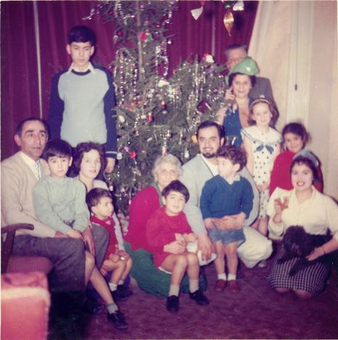

The “red lounge” in Grafton House, 1950s
From left to right: Vaughan with Michael, Joan with Carl, Richard (standing)
Mer-Mer with Jonny, Charlie with Neil, Willie and Helen (standing),
Louisa, Jackie , Jackie Wilson

The most memorable present given to me in Grafton House, was a beautiful doll’s house. It was from my parents who had brought it along from Germany and had hidden it in the car. Looking back, I don’t think the family were particularly indulgent or ostentatious when it came to giving presents. There was a joke going around among the family that Nana (‘Aunty Elly’ to most) gave all the male members of the family the same present every year: a tub of Brylcreem. And Mer-Mer’s present would more often than not be a warm pullover or jumper which he had knitted herself.

Christmas Day was the only time in my experience when the entire family gathered at the large table in the dining room to have their Christmas dinner. I think they followed the English tradition of having roast turkey with various trimmings.

Christmas engrained itself in our memories as a very special time, indeed.

Darmstadt

And then came that memorable Christmas which for some reason or other we were planning to spend not in London but at home in Darmstadt. There was a nicely decorated Christmas tree in our lounge, the base of which was covered in presents. But one morning, not long before Christmas Eve, Dad did not go to work, instead, he stayed at home, and in his pyjamas. He was obviously in some sort of pain, and seemed to find it difficult to walk. The doctor came and prescribed rest and hot compresses, but then that doctor went on holiday and another doctor came and prescribed cold compresses. Things kept getting worse, though, and eventually my Dad had to go to hospital to have an operation. He had to stay in hospital over the Christmas days. Suddenly Mum and me were on our own, and now the Christmas tree and the presents looked at us with sad reproach.

We went to visit my Dad every afternoon, taking taxis (not the tram, of course). He was in bed in a nice large and very clean hospital room all on his own, but he did not seem to have much appetite, for the tray with his mainly untouched meal usually sat on the hospital table beside him. He gladly let me have his dinner, and I finished it all; that hospital food was really nice.

After a week or so my Dad was home again, and everything was back to normal. Actually, it wasn’t. I did not learn about the true impact of that operation until years later. It spelt the irreversible end of my parents’ love life.

Then there was the time when Dad talked a lot about us moving to South Africa.
South Africa! That was at the other end of the world! Apparently an opportunity was presenting itself for us to live in a town called Windhuk (Windhoek). He tried to sell us the advantages of such a move; South Africa was a beautiful, hot, eternally sunny country, and we would live in a grand house, and we would have servants to do all the work for us; we would be very well off there, because we were white and intelligent and so we would belong to the privileged ruling class, whereas the natives, including the servants, were black. He used strange, faintly German sounding words like apartheid and Afrikaans when talking about South Africa. It sounded like fairyland, but I did not hear Mum making any comments about this whole idea, she seemed oddly silent; I suppose the prospect of being so far away from the family in England did not appeal to her.

Move we would again – but not to South Africa. It must have been within this context that Mum once pointed out that Nana sometimes travelled, or had travelled, to South Africa where she apparently deposited some of her fortune in a bank or two.

Apropos Windhuk: and South Africa:

WIKIPEDIA, March 2008
Windhoek (pronounced /ˈvɪntˌhʊk/, sometimes in German: Windhuk) is the capital city of the Republic of Namibia.[…] Germany occupied the region in 1885, and the city became the
seat of colonial rule in 1892 as the capital of the colony of German South-West Africa (Deutsch-Südwestafrika). During World War I Windhoek was captured by South African troops and became a South African Mandate under the League of Nations. Until the independence of Namibia was inaugurated in 1990, Windhoek was recognised as the capital city of South West Africa as administered by the South African government. It continues today as the capital city of the Republic of Namibia.

***

Kurseong

And so, tucked away in the magic Himalayas, carefully protected and under the watchful eyes of the British nuns, Gladys turned from a child into a lively and strikingly attractive young woman. Hardly a shadow darkened those formative years, although Gladys later told her daughter that she had very much wanted to learn to play the piano and had even started taking lessons with one of the nuns. However, the teaching technique routinely employed in those piano lessons had been such that a wrongly played note would be sanctioned instantly by a painful strike across the offending knuckles with a sharp ruler, and this, regretfully, she had not been able to bear, with the result that she quickly stopped taking those lessons.

Apart from acting, Gladys developed a particular liking for history, or rather, for the history of the British Royal Family. This must have been taught by those British nuns quite extensively, and presumably, quite patriotically, and even decades later Gladys still knew by heart the dates and details of all the royal births, deaths, marriages and coronations, from the present back to the notorious Henry VIII and his six wives,.

Judging from her own reflections upon those years at St. Helen’s Convent it seems that Gladys loved school and took an active part in school life; she was a dedicated girl guide, loved the outdoors, and thoroughly enjoyed participating in the various school plays that would be put on stage every so often. She was happy in Kurseong.

.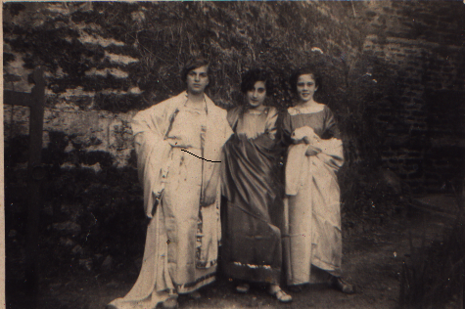

St. Helen’s Convent, Kurseong, 1930s
Pupils in stage costumes, in the middle: Gladys

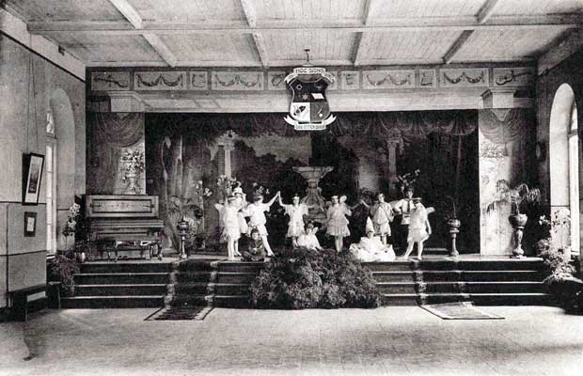

An archive photo of the stage at St. Helen’s Convent, Kurseong

Gladys must have left school when she was about seventeen, and undoubtedly she achieved some solid qualifications, although she made no mention of achieving higher education standards. She seems to have continued the family tradition of leaving no paper trail whatsoever, for she did not keep a single school report or certificate. And she was never given an explanation as to why she was known all those years at St. Helen’s Convent not as Gladys Khayat, but as Gladys Bennett, a surname which had no meaning or association whatsoever for her. This did not bother her, though, and she shrugged it off like she would so many other things in the years to come.

***

Darmstadt

Life was good in Orangerieallee. We had friends and nice neighbours. There was a girl living in the flat below who was my age, and we played together in the afternoons. She had a most unusual and very Germanic sounding name: Burgunde. Then there were the two friendly ladies who were sharing a flat and who had a beautiful shiny piano in their lounge. One beautiful summer’s day they took me on my first visit to an outdoor swimming pool where they spent time with me at the shallow end, showing me how to swim. Germany’s outdoor pools are huge and extremely popular places, and on hot and sunny days everybody is out there, swimming and splashing in the water, sun lounging on the vast and immaculately kept lawns, enjoying ice creams and delicious Frankfurter hotdogs. We as a family did not take part in such ‘low class’ activities, partly perhaps because Mum could not swim, and, having been brought up in India, the idea of sunbathing was alien to her, but mainly. I suppose, because appearing half naked in public was something which people of my Dad’s standing simply did not do..

Once we had a visit from Tante Ilse, my German aunt, who lived in Hamburg with her son whom she was bringing up all on her own.. Tante Ilse was an artist, but now worked for a living. In the past she had created wonderful oil paintings, and book illustrations, and she was also a sculptor and a potter.

On this occasion Tante Ilse visited us on her own, without her son. She stayed with us for a few days, and two little events made this time a memorable one for me. The first event occurred when Tante Ilse decided to take me to a museum.. Well, I had never been to a museum before, but being there with someone like my aunt who kept explaining things to me and pointing out fascinating details in the display cases was a truly mind-expanding experience.

The other event turned into a rescue operation. At my primary school we had a subject called Handarbeiten (needle craft). I was usually quite good at it, and I had neatly crocheted a yellow and pink and very thick Topflappen (oven cloth) and given it to Mum. But now we were required to knit a sock, using four knitting needles, and I was not coping with this task. I had brought my half-finished sock home, and I had to produce the completed item at the next needlecraft lesson. That sorry sock had turned into a terrible knotted muddle and I was deeply troubled that I was not going to be able to produce my homework. I had no one to turn to, for Mum certainly did not know the first thing about needle work or knitting. But then, by a happy coincidence, Tante Ilse happened to arrive just as this unnerving episode was unfolding.. She took one expertly look at my poor sock, did a bit of unravelling and then swiftly knitted the offending object to the end. Not without a grateful sense of last minute rescue did I produce my homework cheat to the needlecraft teacher at the next lesson. Tante Ilse was to remain a very special and much admired person in my life.

Apropos homework cheat. There was another time when I despaired. This time it was for the lesson Zeichnen (drawing), and we were to produce a drawing of the well-known legend of ‘St. Martin and the Cloak’. St. Martin is sitting on his horse, and, seeing a scantily dressed beggar, he impulsively cuts his own military cloak in half with his sword in order to share it with the beggar who later turns out to be Jesus in disguise. I did not even know where to start to outline such a complicated scene.

And again, I was rescued by a happy chance. We went to visit my parents’ friends, Madeleine and Ernest Pleser, the ones who owned the yeast factory, and I happened to mention my depressing homework problem. Their son Cornelius, who was a few years older than me and very artistic and of a kind and friendly nature, knew how to draw really well, so he went and got his drawing pad and pencil and swiftly, magically, sketched out the scene for me while I watched in utter amazement as horse and rider, beggar, sword and cloak materialized on the paper. All I needed to do now was colour the drawing in, and that I knew how to do.

I suppose, strictly speaking, my parents, Tante Ilse, the Pleser family, me - we were all involved in cheating, really. But it did not feel wrong. I was a good and conscientious learner, but in these two cases the technique for producing the homework, be it knitting or drawing, had simply not been taught properly.

Fate was staking its path, and the trajectory of my life was being set in negatives. Not singing Not needlework. Not drawing.

Being useless at singing, drawing and needlework did not bother me much, though, since I was doing alright in all the other subjects, and, above all, I was increasingly enjoying my ballet lessons, now that I had been put on toes which meant I was dancing in proper ballet shoes. I practised regularly at home, could do cartwheels, the splits and the ‘bridge’ (bend backwards in an arch until my hand touched the floor) and I also conscientiously did the rather painful foot-bending exercises.

Easter 1963 approached and with it the end of the primary school years. My school report was such that I was sent to a Gymnasium (grammar school) to complete a school course of all in all thirteen years. The Viktoriaschule was an all girls grammar school, not too far from our flat. Now life took on a whole new dimension, with new teachers, a new class, and interesting new subjects.

The most exotic and most eagerly anticipated new subject for everybody was English - our first foreign language. Not mine, since I was bilingual, but I did have the spelling to learn, to which I applied myself with great enthusiasm. Having cousins in London meant that I already knew what we were now learning about English schools: pupils had to wear uniforms, crisp white shirts, ties, and blazers sporting the school emblem, and they had to stay in school until four o’clock, and the schools had large canteens where the whole school assembled at lunch time to have their hot school dinners every day. This kind of life sounded quite peculiar to us for whom school ended by latest half past one when we all rushed home to our Mums’ home cooked lunches.

Then, after a few weeks, something very strange happened at the school front. We were informed that a big new change was being introduced concerning our school day. We were going to have lessons in the afternoon, on one day a week, and we would have to return to school, after our lunch break at home, for one or two hours of lessons. This was indeed unheard of.

That newly introduced afternoon lesson for our particular class was needlecraft (that subject again), and so, on a given weekday, we wandered back to school after lunch and learnt how to work with sewing machines. There was no particular problem or challenge in this. But, as luck would have it, this afternoon lesson coincided with my ballet class. There was no way out. The school lessons were compulsory. So no more ballet.

Being a shy and rather awkward creature I was not a popular group person, but I was not actively rejected, bullied, or friendless either. I lived contentedly on the fringes of group life, happy to be simply overlooked by the ‘in’ crowd of the class. So, unsurprisingly, I usually had only a very small circle of friends who belonged to the same social periphery.

During those first months at Viktoriaschule I made friends with only one girl from my class. She was quite shy, too, and a little plump, and she was also drifting around on her own, not being taken notice of much by the others. One day she invited me to her home for lunch after school. She came from a large family and they all lived in a rather small flat somewhere in our neighbourhood. Her dad happened to be at home at the time, and I remember thinking what a warm, friendly and cheerful family they were. They reminded me of Uncle Vaughan and Grafton House.

That evening my parents asked me how I had enjoyed the visit to my new friend’s home and casually inquired what my friend’s dad did for a living. I told them that he was a tram driver, and instantly my parents froze.

“There is something you have to understand”, they said, rather haughtily, “those people are the wrong company for you. They do not belong in our social circle. We cannot have you befriending the daughter of a tram driver.”

I was shocked, stunned, upset, mystified.. Try as I might, I could not figure out what my friendship with the girl had to do with her dad’s job. For days I walked around thinking about this. What was wrong with being a tram driver? And what was wrong with my new friend? I could not understand why my parents were rejecting people who were kind and who wanted to be friends with me.

Something in me rebelled and grew stubborn. This girl was the only friend I had at that school and I was not willing to give up that friendship for no apparent reason.. I did not need to battle this one out, though, for life was about to take a sharp new turn.

Soon after the episode with the tram driver’s daughter Mum informed me that we were going to leave Darmstadt. The company Dad was working for, Modag/Demag, so I was told, was changing its production line from diesel engines to plastics, and Dad happened to have no expertise for this new market. Therefore Dad needed to take leave of Modag, and he had been offered a very good position with an English company based in Frankfurt.

So we moved to Frankfurt. Once again the miniature bottles from “the bar” were the first items Mum and me wrapped in layers of old newspaper and packed into removal boxes. This time my parents arranged for me to stay for a few days with their friends, the Plesers, while the removal was taking place. Frankfurt was only about half an hour’s drive north of Darmstadt, and in the same Bundesland (state of the Federal Republic of Germany), Hessen. When my parents finally collected me and took me to our new flat in Beethovenstrasse 26, Frankfurt, it was already decorated and furnished, and most of the boxes had been unpacked.

My parents kept in touch with their Darmstadt friends, family Pleser and family Bender, but I lost contact with Burgunde, the neighbours’ girl, and with the tram driver’s daughter whose name I cannot even remember.

